CHAPTER-1

PROBLEM DEFINITION

INTRODUCTION

Our project report is on “Online Shopping “. In this website, we had made an attempt to filter the products according the famous known brands in that particular product. With the help of our website, it will be very easy for the users to choose the top brands according to their preference and then have the product of that particular brand only. They can explore across the website and find the products for men, women, kids and home.

The website consists of web pages of the products and their respective brands. The various products are further segregated into various brands. The logical manner in which the brands are arranged makes it convenient for the user to take a purchase according to his/her choice. Not only this, there is a webpage which consist of information regarding the dressing sense and how a person can match up with various brands. it guides a user to dress up according to a particular occasion.

This website also consists of hyperlinks such as men, women, kids, home appliances, contact us, about us, guide to dress and so on. From this hyperlink, we can get feedback about the information that the user acquires from the website and they can also comment and express their views on it. Furthermore, the back to top button makes it easy to jump on the top of the page directly without scrolling the mouse million times.

PROBLEMS IN EXISTING SYSTEM

1. Current website system includes enormous data all mixed up, which makes difficult for the user to choose the desired product amongst the wide list of items.
2. There is currently no website that provides user the guide to dress.
3. There is no personal touch with the customer from the company’s end after an order is made. This makes the customer a little concerned about the safety of his confidential information.
4. A customer is sometimes confused about what to buy and what will suit their personality. Though, after surfing for hours they don’t reach to a conclusion and no website helps a customer in solving this issue.
   1. OBJECTIVES OF PROPOSED SYSTEM
5. This system provides a complete support for their customers to make them stand out of the crowd.
6. The biggest reason of people not shopping online the concern for security. Shopping Paradise gives them a call after an order this made to assure them that their money is safe and that they will get their order on time.
7. It also provides a user look book or a guide to dress according to the trend going on
8. There is proper tracking of the order. Wherever the product is, the in charge of that place send the location to the customer to keep the customer updated.
9. The feedback section helps us in improving the quality of the website to its best.
10. The products are very easy to access with their respective brands due to the logical placements of the brands.
11. It makes the customer feel like home as they can contact us as many times as they want.

2**.** DATA COLLECTION

1. [WWW.FASHIONBEANS.COM](http://WWW.FASHIONBEANS.COM)

Fashion Beans keeps the detailed information regarding the latest trend going on in men, kids and women section. Not only this, it also tells how you can pair up your different clothing and make it your unique outfit. It takes into consideration every part of your outfit ranging from a cap to shoes.

1. [WWW.PINTEREST.COM](http://WWW.PINTEREST.COM)

This website includes the pins of various people. It basically tells indirectly what people are liking more these days. This information helps us to great extent as because of this it’s easy for us to incorporate the dressing’s according to the people’s taste.

1. [WWW.LEE.COM](http://WWW.LEE.COM)
2. [WWW.MUFTI.COM](http://WWW.MUFTI.COM)
3. [WWW.WRANGLER.COM](http://WWW.WRANGLER.COM)

3. CONTRIBUTION OF THE TEAM MEMBERS IN SOFTWARE DEVELOPMENT:

|  |  |
| --- | --- |
| Name | Job To Be Done |
| Shrutika Bansal | Database Introduction / System Analysis / Coding / Designing / Documentation |
| Shubham Syal | Documentation / Coding / System Analysis |
| Akhil Gujral |  |
| Simaran Kochar | ---- |

Table no. 1.1: Job done by the team

CHAPTER-2

SYSTEM ANALYSIS AND DESIGN

* 1. Block diagram:

Cartatment

Added to

Visits Views Result in

Order

Products

Website

Customer

Gives and takes Generates

Suggestions Updates

Bills Bills

Adminatment

Figure 2.1: Block diagram of Online Shopping Website

* 1. Sitemap

**Contact Us**

**Men**

**Women**

**Kids**

**Guide to Dress**

Party Wear

Ethinic Wear

Shirts

Clothes

Office Wear

Tops/Dresses

Bottoms

Books

Accessories

Accessories

Casuals

Figure 2.2:- Site Map Of Online Shopping Website

* 1. E-R diagram:

PRODUCT

PAYMENT

CUSTOMER

Does

Buys

Of

Adds

SUPPLIER

ADMIN

Supplies

Figure 2.3:- ER Diagram of Online Shopping Website

* 1. Database Design:

|  |  |  |  |  |
| --- | --- | --- | --- | --- |
| File Name: Supplier | | | | |
| Field Name | Field Code | Field Type | Size | Description |
| Supplier_ID | ID_01 | AutoNumber | 15 | A Unique Code |
| Supplier_Name | Name_02 | Alphabetic | 15 | Name of the supplier |
| Company_Name | Comp_03 | Alphabetic | 30 | Name of the company |
| Product_Description | PD_04 | Alphabetic | 50 | Details of supplied products |

Table 2.4.1:- Database Description of Brand

|  |  |  |  |  |
| --- | --- | --- | --- | --- |
| File Name: Customer | | | | |
| Field Name | Field Code | Field Type | Size | Description |
| Customer_ID | Cid_05 | AutoNumber | 5 | A unique code |
| First_Name | FN_06 | Alphabetic | 15 | First name of customer |
| Last_Name | LN_07 | Alphabetic | 15 | Last name of customer |
| Product_ID | CP_08 | Alphabetic | 20 | Product selected by customer |
| Customer_username | Cun_09 | Alphabetic | 20 | Username of customer |
| Customer_password | Cpass_10 | Alphabetic | 20 | Password of customer |
| Customer_address | Cadd_11 | Alphabetic | 30 | Address of the customer |

Table2.4.2:- Database Description of Customer

|  |  |  |  |  |
| --- | --- | --- | --- | --- |
| File Name: Payment | | | | |
| Field Name | Field Code | Field Type | Size | Description |
| Payment_ID | Payid_12 | AutoNumber | 5 | A unique code |
| Amount | Amt_13 | AutoNumber | 5 | Amount of purchase |
| Payment_Type | Typ_14 | Alphabetic | 10 | Medium of payment |

Table 2.4.5:- Database Description of payment

|  |  |  |  |  |
| --- | --- | --- | --- | --- |
| File Name: Product | | | | |
| Field Name | Field Code | Field Type | Size | Description |
| Product_ID | Pno._15 | Alphanumeric | 10 | Unique Id of Product |
| Product_Name | Pnam_16 | Alphabetic | 50 | Name of Product |
| Product_Model | Pmo_17 | Alphanumeric | 20 | Model of the product |
| Product_Price | Ppri_18 | Numeric | 10 | Price of the product |
| Product_Description | PDes_19 | Alphabetic | 20 | Type pf product |

Table 2.4.6:- Database Description of Product

|  |  |  |  |  |
| --- | --- | --- | --- | --- |
| Admin | | | | |
| Field Name | Field Code | Field Type | Size | Description |
| Admin_ID | Aid_20 | AutoNumber | 20 | A unique code |
| Admin_Name | AName_21 | Alphabetic | 20 | Name of the Admin |
| Admin_Password | APass_22 | Alphanumeric | 20 | Password of the Admin |
| Product_ID | PID_23 | AutoNumber | 20 | Product added |

Table 2.4.7:- Database Description of Cart

(ii) Webpage Design

|  |  |  |
| --- | --- | --- |
| INPUT NAME: REGISTRATION FORM | | |
| NAME OF LABEL | DESCRIPTION/PURPOSE | VALIDATION REQUIRED |
| First name | First name of the Customer | Alphabetic |
| Last name | Last name of the Customer | Alphabetic |
| Phone no. | Contact number of the Customer | Numeric |
| Email | e-mail id of the Customer | Alphanumeric |
| Gender | Gender of the Customer | Radio Button |

Table 2.4.8:- Webpage description of Register form

|  |  |  |
| --- | --- | --- |
| INPUT NAME: LOGIN FORM | | |
| NAME OF THE LABEL | DESCRIPTION/PURPOSE | VALIDATION REQUIRED |
| Username | Username of the Customer | Alphabetic |
| Password | Password of the Customer | Alphanumeric |

Table 2.4.9:- Webpage description of login form

|  |  |  |
| --- | --- | --- |
| INPUT NAME: CONTACT US FORM | | |
| NAME OF THE LABEL | DESCRIPTION/PURPOSE | VALIDATION REQUIRED |
| Name | Name of the person | Alphabetic |
| Contact no. | Contact number of the person | Numeric |
| Email-ID | Email ID of the person | Alphanumeric |
| Message | Description | Alphabetic |

Table 2.4.10:- Webpage description of contact us form

|  |  |  |
| --- | --- | --- |
| INPUT NAME: ADD TO CART FORM | | |
| NAME OF THE LABEL | DESCRIPTION/PURPOSE | VALIDATION REQUIRED |
| Name | Name of the customer | Alphabetic |
| Email-ID | Email-ID of the customer | Alphanumeric |
| Phone No. | Contact No. of the customer | AutoNumber |
| Product Type | Type of product purchased | Radio Button |
| Product ID | Unique code of product purchased | AutoNumber |
| Product ID | Unique number of Product | Numeric |
| Product Price | Price of the product | Numeric |

Table 2.4.12:- Webpage description of Add to Cart form

CHAPTER-3

CODING

**HOME PAGE CODING**

<html>

<head>

<title>LETS GO</title>

<style>

.maindrop{

margin-left: 200px;

}

.women{

margin-top: -60px;

margin-left: 100px;

}

.kids{

margin-top: -60px;

margin-left: 200px;

}

.guide{

margin-top: -60px;

margin-left: 305px;

}

.contactus{

margin-top: -60px;

margin-left: 460px;

}

.aboutus{

margin-top: -60px;

margin-left: 590px;

}

.dropbtn {

background-color: black;

color: white;

padding: 16px;

font-size: 16px;

border: none;

cursor: pointer;

}

.dropdown {

position: relative;

display: inline-block;

margin-top: 10px;

margin-left: 310px;

}

.dropdown-content {

display: none;

position: absolute;

background-color: #f9f9f9;

min-width: 160px;

box-shadow: 0px 8px 16px 0px rgba(0,0,0,0.2);

z-index: 1;

}

.dropdown-content a {

color: black;

padding: 12px 16px;

text-decoration: none;

display: block;

}

.dropdown-content a:hover {background-color: #f1f1f1}

.dropdown:hover .dropdown-content {

display: block;

}

.dropdown:hover .dropbtn {

background-color: maroon;

}

.dropbtn {

background-color: black;

color: white;

padding: 16px;

font-size: 16px;

border: none;

cursor: pointer;

}

.dropdown {

position: relative;

display: inline-block;

margin-top: 10px;

margin-left: 210px;

}

.dropdown-content {

display: none;

position: absolute;

background-color: #f9f9f9;

min-width: 160px;

box-shadow: 0px 8px 16px 0px rgba(0,0,0,0.2);

z-index: 1;

}

.dropdown-content a {

color: black;

padding: 12px 16px;

text-decoration: none;

display: block;

}

.dropdown-content a:hover {background-color: #f1f1f1}

.dropdown:hover .dropdown-content {

display: block;

}

.dropdown:hover .dropbtn {

background-color: maroon;

}

.dropbtn {

background-color: black;

color: white;

padding: 16px;

font-size: 16px;

border: none;

cursor: pointer;

}

.dropdown {

position: relative;

display: inline-block;

margin-top: 10px;

margin-left: 210px;

}

.dropdown-content {

display: none;

position: absolute;

background-color: #f9f9f9;

min-width: 160px;

box-shadow: 0px 8px 16px 0px rgba(0,0,0,0.2);

z-index: 1;

}

.dropdown-content a {

color: black;

padding: 12px 16px;

text-decoration: none;

display: block;

}

.dropdown-content a:hover {background-color: #f1f1f1}

.dropdown:hover .dropdown-content {

display: block;

}

.dropdown:hover .dropbtn {

background-color: maroon;

}

.dropbtn {

background-color: black;

color: white;

padding: 16px;

font-size: 16px;

border: none;

cursor: pointer;

}

.dropdown {

position: relative;

display: inline-block;

margin-top: 10px;

margin-left: 210px;

}

.dropdown-content {

display: none;

position: absolute;

background-color: #f9f9f9;

min-width: 160px;

box-shadow: 0px 8px 16px 0px rgba(0,0,0,0.2);

z-index: 1;

}

.dropdown-content a {

color: black;

padding: 12px 16px;

text-decoration: none;

display: block;

}

.dropdown-content a:hover {background-color: #f1f1f1}

.dropdown:hover .dropdown-content {

display: block;

}

.dropdown:hover .dropbtn {

background-color: maroon;

}

.dropbtn {

background-color: black;

color: white;

padding: 16px;

font-size: 16px;

border: none;

cursor: pointer;

}

.dropdown {

position: relative;

display: inline-block;

margin-top: 10px;

margin-left: 210px;

}

.dropdown-content {

display: none;

position: absolute;

background-color: #f9f9f9;

min-width: 160px;

box-shadow: 0px 8px 16px 0px rgba(0,0,0,0.2);

z-index: 1;

}

.dropdown-content a {

color: black;

padding: 12px 16px;

text-decoration: none;

display: block;

}

.dropdown-content a:hover {background-color: #f1f1f1}

.dropdown:hover .dropdown-content {

display: block;

}

.dropdown:hover .dropbtn {

background-color: maroon;

}

.dropbtn {

background-color: black;

color: white;

padding: 16px;

font-size: 16px;

border: none;

cursor: pointer;

}

.dropdown {

position: relative;

display: inline-block;

margin-top: 10px;

margin-left: 210px;

}

.dropdown-content {

display: none;

position: absolute;

background-color: #f9f9f9;

min-width: 160px;

box-shadow: 0px 8px 16px 0px rgba(0,0,0,0.2);

z-index: 1;

}

.dropdown-content a {

color: black;

padding: 12px 16px;

text-decoration: none;

display: block;

}

.dropdown-content a:hover {background-color: #f1f1f1}

.dropdown:hover .dropdown-content {

display: block;

}

.dropdown:hover .dropbtn {

background-color: maroon;

}

#social-icon-wrapper {

width: 200px;

height: auto;

margin-left: 1100px;

margin-top: -30px;

}

.social-icon {

display: block;

width: 61px;

height: 60px;

float: left;

margin-top: 30px;

margin-right: 5px;

text-align: left;

background: transparent url(http://digital-hideaway.com/always/social-icons.png) 0 0 no-repeat;

background-size: 200px; }

#twitter {

background-position: 0px 0px;

-webkit-transition: all 0.3s ease;

transition: all 0.3s ease; }

#twitter:hover {

background-position: 0px -62px; }

#facebook {

background-position: -69px 0px;

-webkit-transition: all 0.3s ease;

transition: all 0.3s ease; }

#facebook:hover {

background-position: -69px -62px; }

#linkedin {

background-position: -139px 0px;

-webkit-transition: all 0.3s ease;

transition: all 0.3s ease; }

#linkedin:hover {

background-position: -139px -62px; }

.P1{

width:220px;

height:300px

margin-top:200px;

}

.P2{

width:220px;

height:300px;

margin-top:-10px

margin-right:200px;

}

.P3{

width:220px;

height:300px;

margin-top:-569px;

margin-left:500px;

}

.ILOGO{

width:220px;

height:300px;

margin-top:-90px;

margin-left:250px;

}

.ARROW{

width:220px;

height:300px;

margin-top:-50px;

margin-left:30px;

}

.PARAGRAPH{

margin-top:-50px;

margin-left:300px;

}

.SOCIAL{

margin-top:-125px;

margin-left:1100px;

}

.MB {

border-radius: 50%;

margin-left: 0px;

margin-top: 30px;

}

.HOME {

margin-left: 65px;

margin-top: -70px;

}

.SHOP {

margin-left: 50px;

margin-top: -70px;

}

.M{

margin-top: -100px;

}

</style>

</head>

<body>

<hr width=1200px color=black align=top size=5>

&nbsp &nbsp &nbsp &nbsp &nbsp &nbsp &nbsp &nbsp &nbsp &nbsp <a href="file:///C:/Users/Test/Desktop/WEBSITE/my%20account.html"><font color=black>My Account</font></a> &nbsp&nbsp|&nbsp&nbsp <a href="file:///C:/Users/Test/Desktop/WEBSITE/add%20to%20cart%20form.html"><font color=black>Add to Cart</font></a>&nbsp &nbsp| &nbsp&nbsp<a href="file:///C:/Users/Test/Desktop/WEBSITE/login.html"><font color=black>Login</font></a>&nbsp&nbsp |&nbsp&nbsp <a href="file:///C:/Users/Test/Desktop/WEBSITE/register.html"><font color=black>Register</font></a>

<hr color=lightgrey width=1200px size=1>

<div class=MB>

<a href="file:///C:/Users/Test/Desktop/WEBSITE/go%20lets.html"><img src="C:\Users\Test\Desktop\WEBSITE\unnamed.png" height=55 width=55></a>

</div>

<div class=HOME>

<h1><font face="Monotype Corsiva" size=30>HOME</font></h2>

</div>

<div class=SHOP>

<p align=top><font face="calligraph421 BT" color=darkyellow size=50><h3 align=center>SHOPAHOLIC</h1></font></p>

<hr color=lightgrey width=1200px size=1>

</div>

<div class="maindrop">

<div class="dropdown">

<button class="dropbtn">&nbsp&nbsp Men &nbsp&nbsp </button>

<div class="dropdown-content">

<a href="file:///C:/Users/Test/Desktop/WEBSITE/frameset.mens%20shirts%20ALL.html">Shirts</a>

<a href="file:///C:/Users/Test/Desktop/WEBSITE/frameset.mens%20jeans%20ALL.html">Bottoms</a>

<a href="file:///C:/Users/Test/Desktop/WEBSITE/frameset.mens%20accessories%20ALL.html">Accessories</a>

</div>

</div>

<div class="women">

<div class="dropdown">

<button class="dropbtn"> Women </button>

<div class="dropdown-content">

<a href="file:///C:/Users/Test/Desktop/WEBSITE/frameset.women%20suits%20ALL.html">Ethnic Wear</a>

<a href="file:///C:/Users/Test/Desktop/WEBSITE/frameset.women%20tops,dress%20ALL.html">Tops / Dresses</a>

<a href="file:///C:/Users/Test/Desktop/WEBSITE/frameset.women%20accessories%20ALL.html">Accessories</a>

</div>

</div>

</div>

<div class="kids">

<div class="dropdown">

<button class="dropbtn"> &nbsp&nbsp Kids &nbsp&nbsp</button>

<div class="dropdown-content">

<a href="file:///C:/Users/Test/Desktop/WEBSITE/frameset.kids%20clothes%20ALL.html">Clothes</a>

<a href="file:///C:/Users/Test/Desktop/WEBSITE/frameset%20kids%20books%20ALL.html">Books</a>

</div>

</div>

</div>

<div class="guide">

<div class="dropdown">

<button class="dropbtn">Guide To Dress</button>

<div class="dropdown-content">

<a href="file:///C:/Users/Test/Desktop/WEBSITE/guide%20to%20gress%20party.html">Party Wear</a>

<a href="file:///C:/Users/Test/Desktop/WEBSITE/guide%20to%20dress%20office.html">Office Wear</a>

<a href="file:///C:/Users/Test/Desktop/WEBSITE/guide%20to%20dress%20casual%20wear.html">Casuals</a>

</div>

</div>

</div>

<div class="contactus">

<div class="dropdown">

<a href="file:///C:/Users/Test/Desktop/WEBSITE/contact.html"><button class="dropbtn">Contact Us</button></a>

<div class="dropdown-content">

</div>

</div>

</div>

</div>

<hr color=black width=1200px size=3><br>

<link rel="stylesheet" href="file:///C:/Users/Test/Downloads/stylesheet.css">

<style>

.mySlides {display:none}

</style>

<div class="w3-content w3-section" style="max-width:500px">

<img class="mySlides" src="C:\Users\Test\Desktop\WEBSITE\Go-Long-in-Maxi-Dresses-Main-Cover-Banner-999x400--cf359.jpg" width=1333 height=450 align=center>

<img class="mySlides" src="C:\Users\Test\Desktop\WEBSITE\women clothing discount.jpg" width=1333 height=450>

<img class="mySlides" src="C:\Users\Test\Desktop\WEBSITE\flipkart-men-clothing.jpg" width=1333 height=450>

</div>

<script>

var myIndex = 0;

carousel();

function carousel() {

var i;

var x = document.getElementsByClassName("mySlides");

for (i = 0; i < x.length; i++) {

x[i].style.display = "none";

}

myIndex++;

if (myIndex > x.length) {myIndex = 1}

x[myIndex-1].style.display = "block";

setTimeout(carousel, 2000); // Change image every 2 seconds

}

</script>

<br><br>

<div class=P1>

<a href="file:///C:/Users/Test/Desktop/WEBSITE/frameset.women%20suits%20ALL.html"><img src="C:\Users\Test\Desktop\WEBSITE\Oct2813_asa_w1.jpg" align="middle" width=450px height=250px></a>

</div>

<br>

<div class=P2>

<a href="file:///C:/Users/Test/Desktop/WEBSITE/frameset.mens%20shirts%20ALL.html"><img src="C:\Users\Test\Desktop\WEBSITE\BusinessCasual.jpg" align="middle" width=450px height=250px></a>

</div>

<div class=P3>

<a href=""><img src="C:\Users\Test\Desktop\WEBSITE\photo-1495121605193-b116b5b9c5fe.jpg" align="middle" width=450px height=515px></a>

</div>

<br><br><br><br><br><br><br><br><br><br><br><br><br><br>

<hr color=black width=1200px size=1 align=middle>

<br>

<img src="C:\Users\Test\Desktop\WEBSITE\Instagram_logo.svg.png" height=90>

<div class=ILOGO>

<img src="C:\Users\Test\Desktop\WEBSITE\ig-logo-email.png" height=70>

<div class=ARROW>

<img src="C:\Users\Test\Desktop\WEBSITE\curved-arrow-pointing-down-left-black-BMF-FINAL.png" height=70>

</div>

</div>

<div class=M>

<img src="C:\Users\Test\Desktop\WEBSITE\for 6.jpeg"> <img src="C:\Users\Test\Desktop\WEBSITE\for 5.jpeg"><img src="C:\Users\Test\Desktop\WEBSITE\mango 2.jpeg"><img src="C:\Users\Test\Desktop\WEBSITE\mango 1.jpeg"><img src="C:\Users\Test\Desktop\WEBSITE\mango 7.jpeg"><img src="C:\Users\Test\Desktop\WEBSITE\mango 3.jpeg"><img src="C:\Users\Test\Desktop\WEBSITE\mango 9.jpeg"><img src="C:\Users\Test\Desktop\WEBSITE\Shirt Arrow 4.jpeg"><img src="C:\Users\Test\Desktop\WEBSITE\Shirt LP 4.jpeg">

<hr color=black width=1200px size=1 align=middle>

<p align=left><font face="calligraph421 BT" color=darkyellow><h1 align=left>SHOPAHOLIC</h1></font></p>

<div class=PARAGRAPH>

<h3><p><font face="Calibri"><b>ABOUT THE SHOP</b><br><br>Shopaholic.com (Shopuccino a Partnership Firm) is a young and vibrant company<br> that aims to provide good quality products for men, women and kids at <br>affordable prices!...<a href="file:///C:/Users/Test/Desktop/WEBSITE/contact.html"><font color=black>Read More</font></a></font></p><h3>

</div>

<div class=SOCIAL>

<h3 align=left><p><font face="Calibri"><b>FOLLOW US ON SOCIAL</font></p></h3>

</div>

<div id="social-icon-wrapper">

<a id="twitter" class="social-icon" href="https://twitter.com/login"></a>

<a id="facebook" class="social-icon" href="https://www.facebook.com/login/"></a>

<a id="linkedin" class="social-icon" href="https://www.linkedin.com/uas/login"></a>

</div>

<br>

<br>

<br>

</body>

</html>

**HOME PAGE OUTPUT**

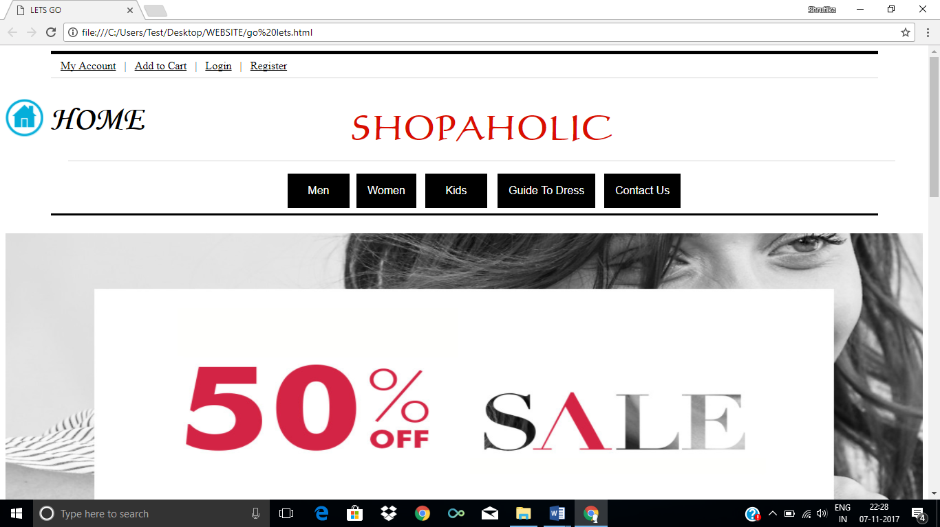

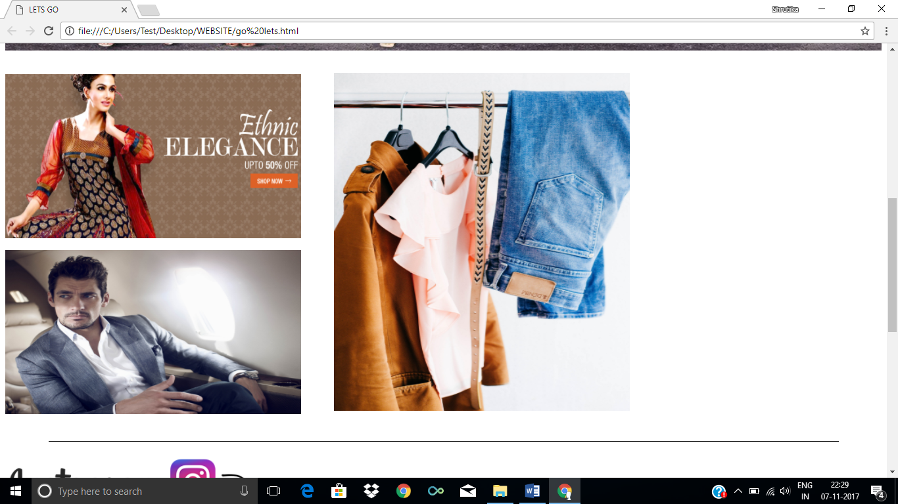

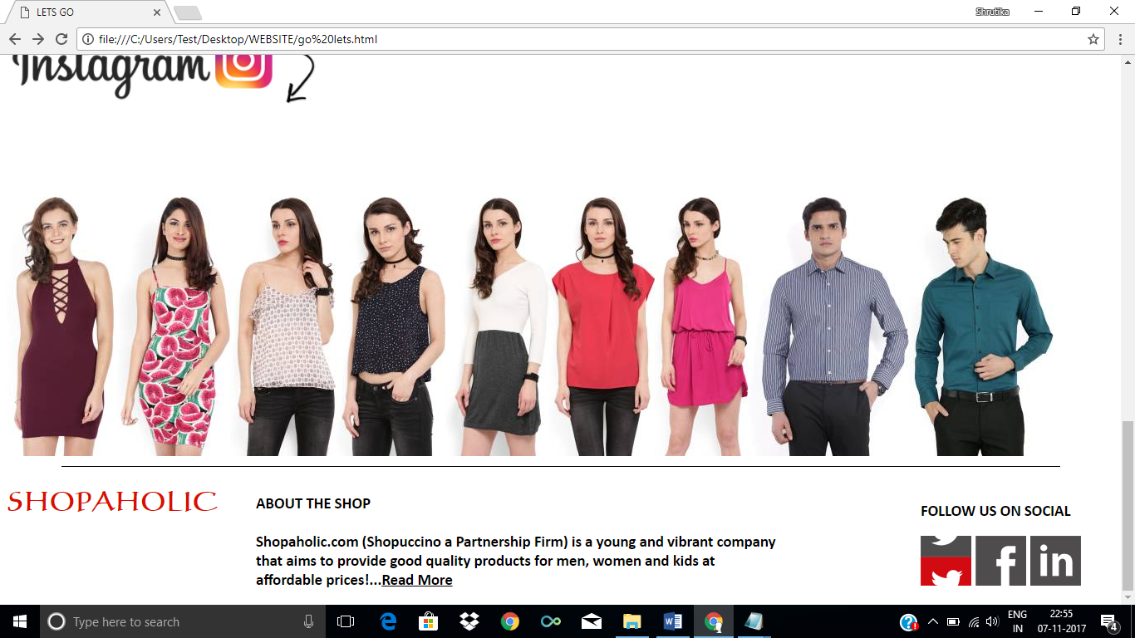

**MY ACCOUNT CODING**

<html>

<head>

<title>ATC Form</title>

<style>

.HOME {

margin-left: 65px;

margin-top: -70px;

}

.SHOP {

margin-left: 50px;

margin-top: -70px;

}

.NAME {

margin-left: 170px;

margin-top: -193px;

}

</style>

</head>

<body>

<hr width=1200px color=black align=top size=5>

&nbsp &nbsp &nbsp &nbsp &nbsp &nbsp &nbsp &nbsp &nbsp &nbsp <a href="file:///C:/Users/Test/Desktop/WEBSITE/my%20account.html"><font color=black>My Account</font></a> &nbsp&nbsp|&nbsp&nbsp <a href="file:///C:/Users/Test/Desktop/WEBSITE/add%20to%20cart%20form.html"><font color=black>Add to Cart</font></a>&nbsp &nbsp| &nbsp&nbsp<a href="file:///C:/Users/Test/Desktop/WEBSITE/login.html"><font color=black>Login</font></a>&nbsp&nbsp |&nbsp&nbsp <a href="file:///C:/Users/Test/Desktop/WEBSITE/register.html"><font color=black>Register</font></a>

<hr color=lightgrey width=1200px size=1>

<div class=MB>

<a href="file:///C:/Users/Test/Desktop/WEBSITE/go%20lets.html" target="_top"><img src="C:\Users\Test\Desktop\WEBSITE\unnamed.png" height=55 width=55></a>

</div>

<div class=HOME>

<h1><font face="Monotype Corsiva" size=30>HOME</font></h2>

</div>

<div class=SHOP>

<p align=top><font face="calligraph421 BT" color=darkyellow size=50><h3 align=center>SHOPAHOLIC</h1></font></p>

<hr color=lightgrey width=1200px size=1>

</div>

<hr color=black width=1200px size=3><br>

<img src="C:\Users\Test\Desktop\Shrutika\FullSizeRender (1).jpg" height=170 width=150>

<div class=NAME>

<h1><font size=150 face="Monotype Corsiva"><u>SHRUTIKA BANSAL</u></font></h1>

<h3><font face="Lucida Handwriting">(M)9711488248<br>

Address : H-92/2, Punajabi Bagh, New Delhi-110026<br>

Products Purchased : 54<br>

Status : Active</font></h3>

</div>

<br>

<h2><font size=150 face="Cataneo BT" color=maroon><u>Orders Placed</u></font></h2>

</div>

**MY ACCOUNT OUTPUT**

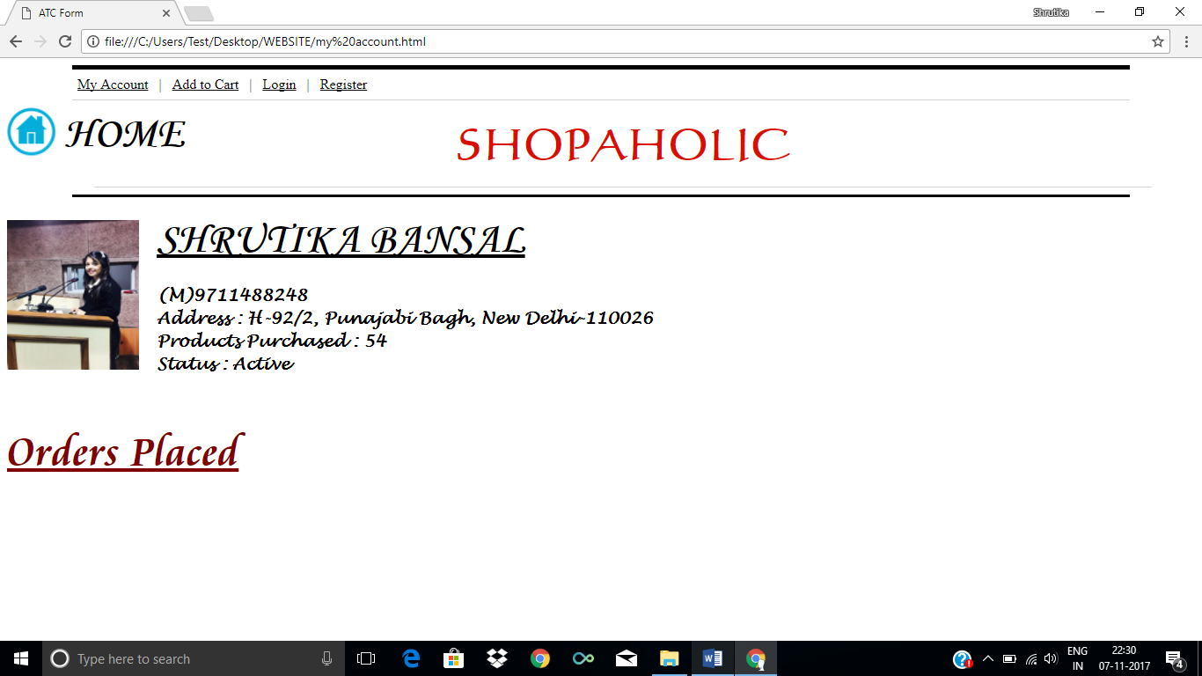

**ADD TO CART CODING**

<html>

<head>

<title>ATC Form</title>

<style>

.HOME {

margin-left: 65px;

margin-top: -70px;

}

.SHOP {

margin-left: 50px;

margin-top: -70px;

}

.f

{

border:solid black;

display:inline-block;

border-shadow:5px 5px 5px;

border-radius: 20px;

padding: 40px;

margin-left: 400px;

}

</style>

</head>

<body>

<hr width=1200px color=black align=top size=5>

&nbsp &nbsp &nbsp &nbsp &nbsp &nbsp &nbsp &nbsp &nbsp &nbsp <a href="file:///C:/Users/Test/Desktop/WEBSITE/my%20account.html"><font color=black>My Account</font></a> &nbsp&nbsp|&nbsp&nbsp <a href="file:///C:/Users/Test/Desktop/WEBSITE/add%20to%20cart%20form.html"><font color=black>Add to Cart</font></a>&nbsp &nbsp| &nbsp&nbsp<a href="file:///C:/Users/Test/Desktop/WEBSITE/login.html"><font color=black>Login</font></a>&nbsp&nbsp |&nbsp&nbsp <a href="file:///C:/Users/Test/Desktop/WEBSITE/register.html"><font color=black>Register</font></a>

<hr color=lightgrey width=1200px size=1>

<div class=MB>

<a href="file:///C:/Users/Test/Desktop/WEBSITE/go%20lets.html" target="_top"><img src="C:\Users\Test\Desktop\WEBSITE\unnamed.png" height=55 width=55></a>

</div>

<div class=HOME>

<h1><font face="Monotype Corsiva" size=30>HOME</font></h2>

</div>

<div class=SHOP>

<p align=top><font face="calligraph421 BT" color=darkyellow size=50><h3 align=center>SHOPAHOLIC</h1></font></p>

<hr color=lightgrey width=1200px size=1>

</div>

<hr color=black width=1200px size=3><br>

<div class=f>

<h1><font face="calligraph421 BT" color=darkyellow size=50>MAKE A PURCHASE</font></h1>

<form action="file:///C:/Users/Test/Desktop/WEBSITE/thank%20you.html">

Name: <input type="text" placeholder="Full Name" name="1"><br><br>

E-mail: <input type="text" placeholder="Email-ID" name="2"><br><br>

Phone: <input type="number" placeholder="Phone No." name="3"><br><br>

Product Type:<input type="radio" name="Type" value=”Clothes” checked> Clothes

<input type="radio" name="Type" value=”Accessories”> Accessories

<input type="radio" name="Type" value=”Others”> Others<br><br>

Product ID: <input type="text" placeholder="Code No." name="4"><br><br>

Product Price: <input type="text" placeholder="Price" name="5"><br><br>

<input type="Submit" value="Submit">

<input type="Reset" value="Reset">

</form>

</div>

</body>

</html>

**ADD TO CART OUTPUT**

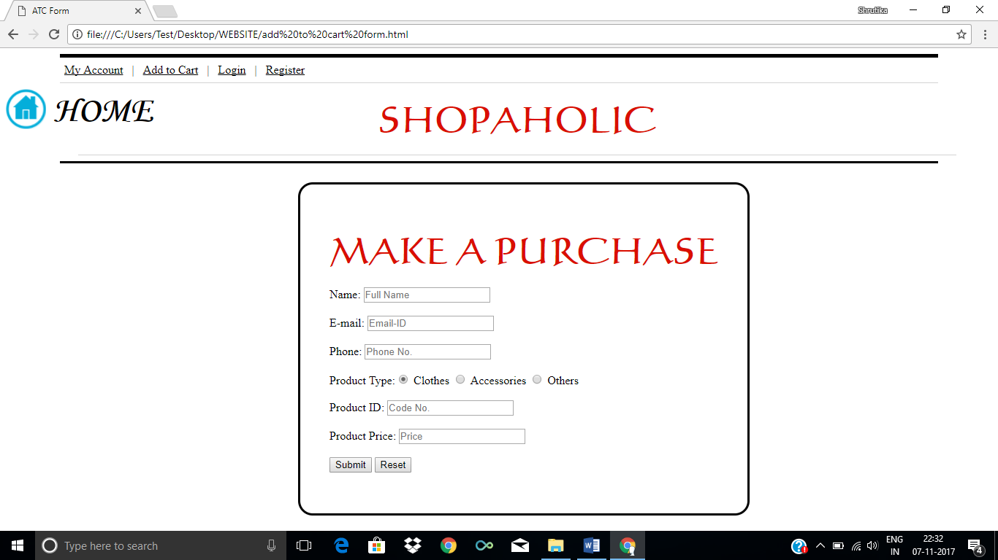

**LOGIN CODING**

<html>

<head>

<title>ATC Form</title>

<style>

.HOME {

margin-left: 65px;

margin-top: -70px;

}

.SHOP {

margin-left: 50px;

margin-top: -70px;

}

.f

{

border:solid black;

display:inline-block;

border-shadow:5px 5px 5px;

border-radius: 20px;

padding: 40px;

margin-left: 550px;

}

</style>

</head>

<body>

<hr width=1200px color=black align=top size=5>

&nbsp &nbsp &nbsp &nbsp &nbsp &nbsp &nbsp &nbsp &nbsp &nbsp <a href="file:///C:/Users/Test/Desktop/WEBSITE/my%20account.html"><font color=black>My Account</font></a> &nbsp&nbsp|&nbsp&nbsp <a href="file:///C:/Users/Test/Desktop/WEBSITE/add%20to%20cart%20form.html"><font color=black>Add to Cart</font></a>&nbsp &nbsp| &nbsp&nbsp<a href="file:///C:/Users/Test/Desktop/WEBSITE/login.html"><font color=black>Login</font></a>&nbsp&nbsp |&nbsp&nbsp <a href="file:///C:/Users/Test/Desktop/WEBSITE/register.html"><font color=black>Register</font></a>

<hr color=lightgrey width=1200px size=1>

<div class=MB>

<a href="file:///C:/Users/Test/Desktop/WEBSITE/go%20lets.html" target="_top"><img src="C:\Users\Test\Desktop\WEBSITE\unnamed.png" height=55 width=55></a>

</div>

<div class=HOME>

<h1><font face="Monotype Corsiva" size=30>HOME</font></h2>

</div>

<div class=SHOP>

<p align=top><font face="calligraph421 BT" color=darkyellow size=50><h3 align=center>SHOPAHOLIC</h1></font></p>

<hr color=lightgrey width=1200px size=1>

</div>

<hr color=black width=1200px size=3><br>

<form action="file:///C:/Users/Test/Desktop/WEBSITE/my%20account.html">

<div class=f>

<h1><font face="calligraph421 BT" color=darkyellow size=50>LOGIN</font></h1>

User Name: <input type="text" name="1"><br><br>

Password: <input type="password" name="2"><br><br>

<input type="Submit" value="Submit">

</form>

</body>

</html>

**LOGIN OUTPUT**

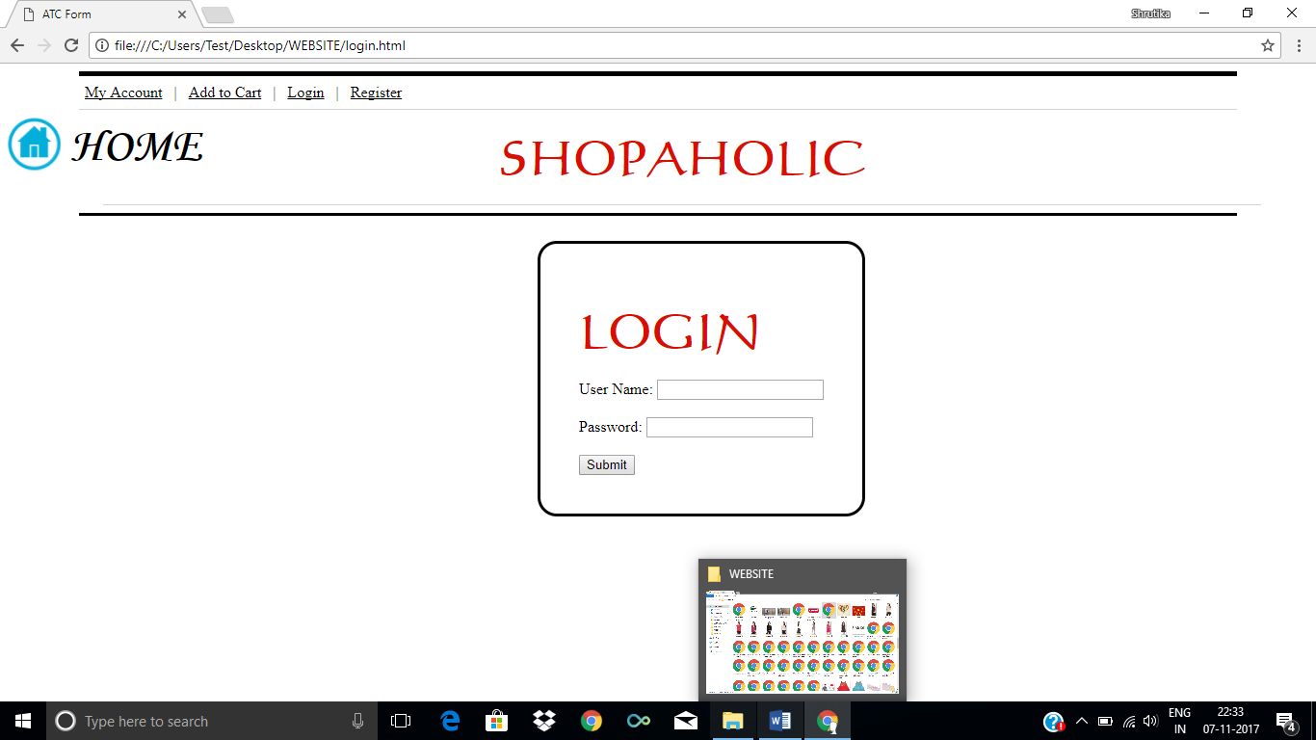

**REGISTER CODING**

<html>

<head>

<title>Register</title>

<style>

.HOME {

margin-left: 65px;

margin-top: -70px;

}

.SHOP {

margin-left: 50px;

margin-top: -70px;

}

.f

{

border:solid black;

display:inline-block;

border-shadow:5px 5px 5px;

border-radius: 20px;

padding: 40px;

margin-left: 500px;

}

</style>

</head>

<body>

<body>

<hr width=1200px color=black align=top size=5>

&nbsp &nbsp &nbsp &nbsp &nbsp &nbsp &nbsp &nbsp &nbsp &nbsp <a href="file:///C:/Users/Test/Desktop/WEBSITE/my%20account.html"><font color=black>My Account</font></a> &nbsp&nbsp|&nbsp&nbsp <a href="file:///C:/Users/Test/Desktop/WEBSITE/add%20to%20cart%20form.html"><font color=black>Add to Cart</font></a>&nbsp &nbsp| &nbsp&nbsp<a href="file:///C:/Users/Test/Desktop/WEBSITE/login.html"><font color=black>Login</font></a>&nbsp&nbsp |&nbsp&nbsp <a href="file:///C:/Users/Test/Desktop/WEBSITE/register.html"><font color=black>Register</font></a>

<hr color=lightgrey width=1200px size=1>

<div class=MB>

<a href="file:///C:/Users/Test/Desktop/WEBSITE/go%20lets.html" target="_top"><img src="C:\Users\Test\Desktop\WEBSITE\unnamed.png" height=55 width=55></a>

</div>

<div class=HOME>

<h1><font face="Monotype Corsiva" size=30>HOME</font></h2>

</div>

<div class=SHOP>

<p align=top><font face="calligraph421 BT" color=darkyellow size=50><h3 align=center>SHOPAHOLIC</h1></font></p>

<hr color=lightgrey width=1200px size=1>

</div>

<hr color=black width=1200px size=3><br>

<form action="file:///C:/Users/Test/Desktop/WEBSITE/login.html">

<div class=f>

<h1><font face="calligraph421 BT" color=darkyellow size=50>NEW USER</font></h1>

First Name: <input type="text" name="1"><br><BR>

Last Name: <input type="text" name="2"><br><BR>

Phone: <input type="text" name="3"><br><BR>

E-mail: <input type="text" name="3"><br><BR>

Gender:<input type="radio" name="gender" value=”Male” checked> Male

<input type="radio" name="Gender" value=”Female”> Female

<input type="radio" name="Gender" value=”Other”> Other<br><BR>

E-mail: <input type="text" name="3"><br><BR>

<input type="Submit" value="Submit">

<input type="Reset" value="Reset">

</form>

</html>

**REGISTER OUTPUT**

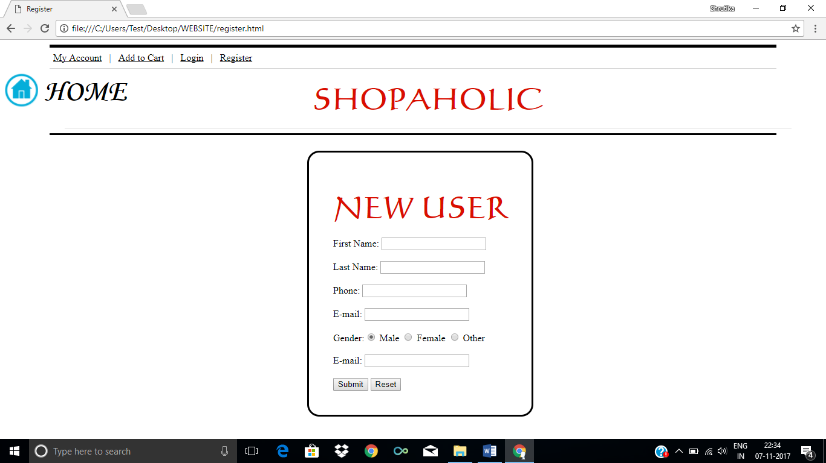

***MEN***

<html>

<head>

<title>Frameset</title>

</head>

<frameset rows="35%,65%" noresize>

<frame name="header" src="file:///C:/Users/Test/Desktop/WEBSITE/common%20header.html" frameborder="0">

<frame name="icons" src="file:///C:/Users/Test/Desktop/WEBSITE/Mens%20Shirts%20ALL.html" frameborder="0">

</frameset>

</frameset>

</html>

ARROW

<html>

<head>

<title>Mens Shirts Arrow</title>

<style>

.P1{

padding:15px;

width:240px;

height:340px;

border: 1px solid white;

}

.p1:hover{

box-shadow: 0 12px 16px 0 rgba(0, 0, 0, 0.24) , 0 17px 50px 0 rgba(0, 0, 0, 0.19);

}

.P2{

padding:15px;

width:240px;

height:340px;

border: 1px solid white;

float: right;

margin-top: -372.5px;

margin-right: 540px;

}

.p2:hover{

box-shadow: 0 12px 16px 0 rgba(0, 0, 0, 0.24) , 0 17px 50px 0 rgba(0, 0, 0, 0.19);

}

.P3{

padding:15px;

width:240px;

height:340px;

border: 1px solid white;

float: right;

margin-top: -372.5px;

margin-right: 280px;

}

.p3:hover{

box-shadow: 0 12px 16px 0 rgba(0, 0, 0, 0.24) , 0 17px 50px 0 rgba(0, 0, 0, 0.19);

}

.P4{

padding:15px;

width:240px;

height:340px;

border: 1px solid white;

float: right;

margin-top: -372.5px;

margin-right: 20px;

}

.p4:hover{

box-shadow: 0 12px 16px 0 rgba(0, 0, 0, 0.24) , 0 17px 50px 0 rgba(0, 0, 0, 0.19);

}

.P5{

padding:15px;

width:240px;

height:340px;

border: 1px solid white;

float: right;

margin-top: 30px;

margin-right: 800px;

}

.p5:hover{

box-shadow: 0 12px 16px 0 rgba(0, 0, 0, 0.24) , 0 17px 50px 0 rgba(0, 0, 0, 0.19);

}

.P6{

padding:15px;

width:240px;

height:340px;

border: 1px solid white;

float: right;

margin-top: -370px;

margin-right: 540px;

}

.p6:hover{

box-shadow: 0 12px 16px 0 rgba(0, 0, 0, 0.24) , 0 17px 50px 0 rgba(0, 0, 0, 0.19);

}

</style>

</head>

<body>

<h1 align=center><font face="Constantia">MENS SHIRT ~ARROW~</font></h1>

<div class=P1>

<a href="file:///C:/Users/Test/Desktop/WEBSITE/ADD%20TO%20CART.html" target="_top"><img src="C:\Users\Test\Desktop\WEBSITE\Shirt Arrow 1.jpg" height=300px width=230px><br>

<br><b><font face="Constantia" size=4>Blue Pattern Shirt</font></a></b><br>

<b>Rs. 1,214 &nbsp&nbsp&nbsp <font color="grey"><strike>2,699</strike></font> &nbsp&nbsp&nbsp <font color="green">55% off</font></b>

</div>

<div class=P2>

<a href="file:///C:/Users/Test/Desktop/WEBSITE/ADD%20TO%20CART.html" target="_top"><img src="C:\Users\Test\Desktop\WEBSITE\Shirt Arrow 2.jpg" height=300px width=230px><br>

<br><b><font face="Constantia" size=4>White Dotted Shirt</font></a></b><br>

<b>Rs. 1199 &nbsp&nbsp&nbsp <font color="grey"><strike>2,999</strike></font> &nbsp&nbsp&nbsp <font color="green">60% off</font></b>

</div>

<div class=P3>

<a href="file:///C:/Users/Test/Desktop/WEBSITE/ADD%20TO%20CART.html" target="_top"><img src="C:\Users\Test\Desktop\WEBSITE\Shirt Arrow 3.jpg" height=300px width=230px><br>

<br><b><font face="Constantia" size=4>White Dotted Shirt</font></a></b><br>

<b>Rs. 944 &nbsp&nbsp&nbsp <font color="grey"><strike>2,199</strike></font> &nbsp&nbsp&nbsp <font color="green">57% off</font></b>

</div>

<div class=P4>

<a href="file:///C:/Users/Test/Desktop/WEBSITE/ADD%20TO%20CART.html" target="_top"><img src="C:\Users\Test\Desktop\WEBSITE\Shirt Arrow 4.jpeg" height=300px width=230px><br>

<br><b><font face="Constantia" size=4>Blue n White Striped Shirt</font></a></b><br>

<b>Rs. 1079 &nbsp&nbsp&nbsp <font color="grey"><strike>2399</strike></font> &nbsp&nbsp&nbsp <font color="green">55% off</font></b>

</div>

<div class=P5>

<a href="file:///C:/Users/Test/Desktop/WEBSITE/ADD%20TO%20CART.html" target="_top"><img src="C:\Users\Test\Desktop\WEBSITE\Shirt Arrow 5.jpg" height=300px width=230px><br>

<br><b><font face="Constantia" size=4>Royal Blue Shirt</font></a></b><br>

<b>Rs. 899 &nbsp&nbsp&nbsp <font color="grey"><strike>2,999</strike></font> &nbsp&nbsp&nbsp <font color="green">70% off</font></b>

</div>

<div class=P6>

<a href="file:///C:/Users/Test/Desktop/WEBSITE/ADD%20TO%20CART.html" target="_top"><img src="C:\Users\Test\Desktop\WEBSITE\Shirt Arrow 6.jpg" height=300px width=230px><br>

<br><b><font face="Constantia" size=4>Graffiti Colorful Shirt</font></a></b><br>

<b>Rs. 944 &nbsp&nbsp&nbsp <font color="grey"><strike>2,199</strike></font> &nbsp&nbsp&nbsp <font color="green">57% off</font></b>

</div>

</body>

LOUIS PHILLIPE

<html>

<head>

<title>Mens Shirt LP</title>

<style>

.P1{

padding:15px;

width:240px;

height:340px;

border: 1px solid white;

}

.p1:hover{

box-shadow: 0 12px 16px 0 rgba(0, 0, 0, 0.24) , 0 17px 50px 0 rgba(0, 0, 0, 0.19);

}

.P2{

padding:15px;

width:240px;

height:340px;

border: 1px solid white;

float: right;

margin-top: -372.5px;

margin-right: 540px;

}

.p2:hover{

box-shadow: 0 12px 16px 0 rgba(0, 0, 0, 0.24) , 0 17px 50px 0 rgba(0, 0, 0, 0.19);

}

.P3{

padding:15px;

width:240px;

height:340px;

border: 1px solid white;

float: right;

margin-top: -372.5px;

margin-right: 280px;

}

.p3:hover{

box-shadow: 0 12px 16px 0 rgba(0, 0, 0, 0.24) , 0 17px 50px 0 rgba(0, 0, 0, 0.19);

}

.P4{

padding:15px;

width:240px;

height:340px;

border: 1px solid white;

float: right;

margin-top: -372.5px;

margin-right: 20px;

}

.p4:hover{

box-shadow: 0 12px 16px 0 rgba(0, 0, 0, 0.24) , 0 17px 50px 0 rgba(0, 0, 0, 0.19);

}

.P5{

padding:15px;

width:240px;

height:340px;

border: 1px solid white;

float: right;

margin-top: 30px;

margin-right: 800px;

}

.p5:hover{

box-shadow: 0 12px 16px 0 rgba(0, 0, 0, 0.24) , 0 17px 50px 0 rgba(0, 0, 0, 0.19);

}

.P6{

padding:15px;

width:240px;

height:340px;

border: 1px solid white;

float: right;

margin-top: -370px;

margin-right: 540px;

}

.p6:hover{

box-shadow: 0 12px 16px 0 rgba(0, 0, 0, 0.24) , 0 17px 50px 0 rgba(0, 0, 0, 0.19);

}

.P7{

padding:15px;

width:240px;

height:340px;

border: 1px solid white;

float: right;

margin-top: -370px;

margin-right: 280px;

}

.p7:hover{

box-shadow: 0 12px 16px 0 rgba(0, 0, 0, 0.24) , 0 17px 50px 0 rgba(0, 0, 0, 0.19);

}

.P8{

padding:15px;

width:240px;

height:340px;

border: 1px solid white;

float: right;

margin-top: -370px;

margin-right: -550px;

}

.p8:hover{

box-shadow: 0 12px 16px 0 rgba(0, 0, 0, 0.24) , 0 17px 50px 0 rgba(0, 0, 0, 0.19);

}

.P9{

padding:15px;

width:240px;

height:340px;

border: 1px solid white;

float: right;

margin-top: 20px;

margin-right: 800px;

}

.p9:hover{

box-shadow: 0 12px 16px 0 rgba(0, 0, 0, 0.24) , 0 17px 50px 0 rgba(0, 0, 0, 0.19);

}

.P10{

padding:15px;

width:240px;

height:340px;

border: 1px solid white;

float: right;

margin-top: -373px;

margin-right: 540px;

}

.p10:hover{

box-shadow: 0 12px 16px 0 rgba(0, 0, 0, 0.24) , 0 17px 50px 0 rgba(0, 0, 0, 0.19);

}

.P11{

padding:15px;

width:240px;

height:340px;

border: 1px solid white;

float: right;

margin-top: -373px;

margin-right: 280px;

}

.p11:hover{

box-shadow: 0 12px 16px 0 rgba(0, 0, 0, 0.24) , 0 17px 50px 0 rgba(0, 0, 0, 0.19);

}

</style>

</head>

<body>

<h1 align=center><font face="Constantia">MENS SHIRT ~LOUIS PHILLIPE~</font></h1>

<div class=P1>

<a href="file:///C:/Users/Test/Desktop/WEBSITE/ADD%20TO%20CART.html" target="_top"><img src="C:\Users\Test\Desktop\WEBSITE\Shirt LP 1.jpg" height=300px width=230px><br>

<br><b><font face="Constantia" size=4>Blue n White Chex Shirt</font></a></b><br>

<b>Rs. 1,214 &nbsp&nbsp&nbsp <font color="grey"><strike>2,699</strike></font> &nbsp&nbsp&nbsp <font color="green">55% off</font></b>

</div>

<div class=P2>

<a href="file:///C:/Users/Test/Desktop/WEBSITE/ADD%20TO%20CART.html" target="_top"><img src="C:\Users\Test\Desktop\WEBSITE\Shirt LP 2.jpg" height=300px width=230px><br>

<br><b><font face="Constantia" size=4>Blue n white Striped Shirt</font></a></b><br>

<b>Rs. 1199 &nbsp&nbsp&nbsp <font color="grey"><strike>2,999</strike></font> &nbsp&nbsp&nbsp <font color="green">60% off</font></b>

</div>

<div class=P3>

<a href="file:///C:/Users/Test/Desktop/WEBSITE/ADD%20TO%20CART.html" target="_top"><img src="C:\Users\Test\Desktop\WEBSITE\Shirt LP 3.jpg" height=300px width=230px><br>

<br><b><font face="Constantia" size=4>Green Floral Shirt</font></a></b><br>

<b>Rs. 944 &nbsp&nbsp&nbsp <font color="grey"><strike>2,199</strike></font> &nbsp&nbsp&nbsp <font color="green">57% off</font></b>

</div>

<div class=P4>

<a href="file:///C:/Users/Test/Desktop/WEBSITE/ADD%20TO%20CART.html" target="_top"><img src="C:\Users\Test\Desktop\WEBSITE\Shirt LP 4.jpeg" height=300px width=230px><br>

<br><b><font face="Constantia" size=4>Soothing Green Shirt</font></a></b><br>

<b>Rs. 1079 &nbsp&nbsp&nbsp <font color="grey"><strike>2399</strike></font> &nbsp&nbsp&nbsp <font color="green">55% off</font></b>

</div>

<div class=P5>

<a href="file:///C:/Users/Test/Desktop/WEBSITE/ADD%20TO%20CART.html" target="_top"><img src="C:\Users\Test\Desktop\WEBSITE\Shirt LP 5.jpg" height=300px width=230px><br>

<br><b><font face="Constantia" size=4>Bright Blue Shirt</font></a></b><br>

<b>Rs. 899 &nbsp&nbsp&nbsp <font color="grey"><strike>2,999</strike></font> &nbsp&nbsp&nbsp <font color="green">70% off</font></b>

</div>

<div class=P6>

<a href="file:///C:/Users/Test/Desktop/WEBSITE/ADD%20TO%20CART.html" target="_top"><img src="C:\Users\Test\Desktop\WEBSITE\Shirt LP 6.jpg" height=300px width=230px><br>

<br><b><font face="Constantia" size=4>Regular Black Color shirt</font></a></b><br>

<b>Rs. 944 &nbsp&nbsp&nbsp <font color="grey"><strike>2,199</strike></font> &nbsp&nbsp&nbsp <font color="green">57% off</font></b>

</div>

<div class=P7>

<a href="file:///C:/Users/Test/Desktop/WEBSITE/ADD%20TO%20CART.html" target="_top"><img src="C:\Users\Test\Desktop\WEBSITE\Shirt LP 7.jpg" height=300px width=230px><br>

<br><b><font face="Constantia" size=4>Bright Yellow Shirt</font></a></b><br>

<b>Rs. 759 &nbsp&nbsp&nbsp <font color="grey"><strike>1,899</strike></font> &nbsp&nbsp&nbsp <font color="green">60% off</font></b>

</div>

<div class=P8>

<a href="file:///C:/Users/Test/Desktop/WEBSITE/ADD%20TO%20CART.html" target="_top"><img src="C:\Users\Test\Desktop\WEBSITE\Shirt LP 8.jpg" height=300px width=230px><br>

<br><b><font face="Constantia" size=4>Small Chex Shirt</font></a></b><br>

<b>Rs. 1,214 &nbsp&nbsp&nbsp <font color="grey"><strike>2,699</strike></font> &nbsp&nbsp&nbsp <font color="green">55% off</font></b>

</div>

<div class=P9>

<a href="file:///C:/Users/Test/Desktop/WEBSITE/ADD%20TO%20CART.html" target="_top"><img src="C:\Users\Test\Desktop\WEBSITE\Shirt LP 9.jpg" height=300px width=230px><br>

<br><b><font face="Constantia" size=4>White Formal Shirt</font></a></b><br>

<b>Rs. 1,239 &nbsp&nbsp&nbsp <font color="grey"><strike>3,099</strike></font> &nbsp&nbsp&nbsp <font color="green">60% off</font></b>

</div>

<div class=P10>

<a href="file:///C:/Users/Test/Desktop/WEBSITE/ADD%20TO%20CART.html" target="_top"><img src="C:\Users\Test\Desktop\WEBSITE\Shirt LP 10.jpg" height=300px width=230px><br>

<br><b><font face="Constantia" size=4>Dark Grey Shirt</font></a></b><br>

<b>Rs. 1,394 &nbsp&nbsp&nbsp <font color="grey"><strike>3,099</strike></font> &nbsp&nbsp&nbsp <font color="green">55% off</font></b>

</div>

<div class=P11>

<a href="file:///C:/Users/Test/Desktop/WEBSITE/ADD%20TO%20CART.html" target="_top"><img src="C:\Users\Test\Desktop\WEBSITE\Shirt LP 11.jpg" height=300px width=230px><br>

<br><b><font face="Constantia" size=4>Dark Beige Shirt</font></a></b><br>

<b>Rs. 584 &nbsp&nbsp&nbsp <font color="grey"><strike>1,299</strike></font> &nbsp&nbsp&nbsp <font color="green">55% off</font></b>

</div>

</body>

COLOR PLUS

<html>

<head>

<title>Mens Shirt CP</title>

<style>

.P1{

padding:15px;

width:240px;

height:340px;

border: 1px solid white;

}

.p1:hover{

box-shadow: 0 12px 16px 0 rgba(0, 0, 0, 0.24) , 0 17px 50px 0 rgba(0, 0, 0, 0.19);

}

.P2{

padding:15px;

width:240px;

height:340px;

border: 1px solid white;

float: right;

margin-top: -372.5px;

margin-right: 540px;

}

.p2:hover{

box-shadow: 0 12px 16px 0 rgba(0, 0, 0, 0.24) , 0 17px 50px 0 rgba(0, 0, 0, 0.19);

}

.P3{

padding:15px;

width:240px;

height:340px;

border: 1px solid white;

float: right;

margin-top: -372.5px;

margin-right: 280px;

}

.p3:hover{

box-shadow: 0 12px 16px 0 rgba(0, 0, 0, 0.24) , 0 17px 50px 0 rgba(0, 0, 0, 0.19);

}

.P4{

padding:15px;

width:240px;

height:340px;

border: 1px solid white;

float: right;

margin-top: -372.5px;

margin-right: 20px;

}

.p4:hover{

box-shadow: 0 12px 16px 0 rgba(0, 0, 0, 0.24) , 0 17px 50px 0 rgba(0, 0, 0, 0.19);

}

.P5{

padding:15px;

width:240px;

height:340px;

border: 1px solid white;

float: right;

margin-top: 30px;

margin-right: 800px;

}

.p5:hover{

box-shadow: 0 12px 16px 0 rgba(0, 0, 0, 0.24) , 0 17px 50px 0 rgba(0, 0, 0, 0.19);

}

</style>

</head>

<body>

<h1 align=center><font face="Constantia">MENS SHIRT ~COLOR PLUS~</font></h1>

<div class=P1>

<a href="file:///C:/Users/Test/Desktop/WEBSITE/ADD%20TO%20CART.html" target="_top"><img src="C:\Users\Test\Desktop\WEBSITE\Shirt CP 1.jpg" height=300px width=230px><br>

<br><b><font face="Constantia" size=4>Small Chex Shirt</font></a></b><br>

<b>Rs. 1,214 &nbsp&nbsp&nbsp <font color="grey"><strike>2,699</strike></font> &nbsp&nbsp&nbsp <font color="green">55% off</font></b>

</div>

<div class=P2>

<a href="file:///C:/Users/Test/Desktop/WEBSITE/ADD%20TO%20CART.html" target="_top"><img src="C:\Users\Test\Desktop\WEBSITE\Shirt CP 2.jpg" height=300px width=230px><br>

<br><b><font face="Constantia" size=4>Blue n white Chex Shirt</font></a></b><br>

<b>Rs. 1199 &nbsp&nbsp&nbsp <font color="grey"><strike>2,999</strike></font> &nbsp&nbsp&nbsp <font color="green">60% off</font></b>

</div>

<div class=P3>

<a href="file:///C:/Users/Test/Desktop/WEBSITE/ADD%20TO%20CART.html" target="_top"><img src="C:\Users\Test\Desktop\WEBSITE\Shirt CP 3.jpg" height=300px width=230px><br>

<br><b><font face="Constantia" size=4>Shiny Blue Shirt</font></a></b><br>

<b>Rs. 944 &nbsp&nbsp&nbsp <font color="grey"><strike>2,199</strike></font> &nbsp&nbsp&nbsp <font color="green">57% off</font></b>

</div>

<div class=P4>

<a href="file:///C:/Users/Test/Desktop/WEBSITE/ADD%20TO%20CART.html" target="_top"><img src="C:\Users\Test\Desktop\WEBSITE\Shirt CP 4.jpg" height=300px width=230px><br>

<br><b><font face="Constantia" size=4>Blue Shirt</font></a></b><br>

<b>Rs. 1079 &nbsp&nbsp&nbsp <font color="grey"><strike>2399</strike></font> &nbsp&nbsp&nbsp <font color="green">55% off</font></b>

</div>

<div class=P5>

<a href="file:///C:/Users/Test/Desktop/WEBSITE/ADD%20TO%20CART.html" target="_top"><img src="C:\Users\Test\Desktop\WEBSITE\Shirt CP 5.jpg" height=300px width=230px><br>

<br><b><font face="Constantia" size=4>Pink Floral Shirt</font></a></b><br>

<b>Rs. 899 &nbsp&nbsp&nbsp <font color="grey"><strike>2,999</strike></font> &nbsp&nbsp&nbsp <font color="green">70% off</font></b>

</div>

</body>

UNITED COLORS OF BENETTON

<html>

<head>

<title>Mens Shirt UCB</title>

<style>

.P1{

padding:15px;

width:240px;

height:340px;

border: 1px solid white;

}

.p1:hover{

box-shadow: 0 12px 16px 0 rgba(0, 0, 0, 0.24) , 0 17px 50px 0 rgba(0, 0, 0, 0.19);

}

.P2{

padding:15px;

width:240px;

height:340px;

border: 1px solid white;

float: right;

margin-top: -372.5px;

margin-right: 540px;

}

.p2:hover{

box-shadow: 0 12px 16px 0 rgba(0, 0, 0, 0.24) , 0 17px 50px 0 rgba(0, 0, 0, 0.19);

}

.P3{

padding:15px;

width:240px;

height:340px;

border: 1px solid white;

float: right;

margin-top: -372.5px;

margin-right: 280px;

}

.p3:hover{

box-shadow: 0 12px 16px 0 rgba(0, 0, 0, 0.24) , 0 17px 50px 0 rgba(0, 0, 0, 0.19);

}

.P4{

padding:15px;

width:240px;

height:340px;

border: 1px solid white;

float: right;

margin-top: -372.5px;

margin-right: 20px;

}

.p4:hover{

box-shadow: 0 12px 16px 0 rgba(0, 0, 0, 0.24) , 0 17px 50px 0 rgba(0, 0, 0, 0.19);

}

.P5{

padding:15px;

width:240px;

height:340px;

border: 1px solid white;

float: right;

margin-top: 30px;

margin-right: 800px;

}

.p5:hover{

box-shadow: 0 12px 16px 0 rgba(0, 0, 0, 0.24) , 0 17px 50px 0 rgba(0, 0, 0, 0.19);

}

.P6{

padding:15px;

width:240px;

height:340px;

border: 1px solid white;

float: right;

margin-top: -370px;

margin-right: 540px;

}

.p6:hover{

box-shadow: 0 12px 16px 0 rgba(0, 0, 0, 0.24) , 0 17px 50px 0 rgba(0, 0, 0, 0.19);

}

.P7{

padding:15px;

width:240px;

height:340px;

border: 1px solid white;

float: right;

margin-top: -370px;

margin-right: 280px;

}

.p7:hover{

box-shadow: 0 12px 16px 0 rgba(0, 0, 0, 0.24) , 0 17px 50px 0 rgba(0, 0, 0, 0.19);

}

.P8{

padding:15px;

width:240px;

height:340px;

border: 1px solid white;

float: right;

margin-top: -370px;

margin-right: -550px;

}

.p8:hover{

box-shadow: 0 12px 16px 0 rgba(0, 0, 0, 0.24) , 0 17px 50px 0 rgba(0, 0, 0, 0.19);

}

.P9{

padding:15px;

width:240px;

height:340px;

border: 1px solid white;

float: right;

margin-top: 20px;

margin-right: 800px;

}

.p9:hover{

box-shadow: 0 12px 16px 0 rgba(0, 0, 0, 0.24) , 0 17px 50px 0 rgba(0, 0, 0, 0.19);

}

.P10{

padding:15px;

width:240px;

height:340px;

border: 1px solid white;

float: right;

margin-top: -373px;

margin-right: 540px;

}

.p10:hover{

box-shadow: 0 12px 16px 0 rgba(0, 0, 0, 0.24) , 0 17px 50px 0 rgba(0, 0, 0, 0.19);

}

.P11{

padding:15px;

width:240px;

height:340px;

border: 1px solid white;

float: right;

margin-top: -373px;

margin-right: 280px;

}

.p11:hover{

box-shadow: 0 12px 16px 0 rgba(0, 0, 0, 0.24) , 0 17px 50px 0 rgba(0, 0, 0, 0.19);

}

.P12{

padding:15px;

width:240px;

height:340px;

border: 1px solid white;

float: right;

margin-top: -373px;

margin-right: 20px;

}

.p12:hover{

box-shadow: 0 12px 16px 0 rgba(0, 0, 0, 0.24) , 0 17px 50px 0 rgba(0, 0, 0, 0.19);

}

.P13{

padding:15px;

width:240px;

height:340px;

border: 1px solid white;

float: right;

margin-top: 13px;

margin-right: 800px;

}

.p13:hover{

box-shadow: 0 12px 16px 0 rgba(0, 0, 0, 0.24) , 0 17px 50px 0 rgba(0, 0, 0, 0.19);

}

.P14{

padding:15px;

width:240px;

height:340px;

border: 1px solid white;

float: right;

margin-top: -373px;

margin-right: 540px;

}

.p14:hover{

box-shadow: 0 12px 16px 0 rgba(0, 0, 0, 0.24) , 0 17px 50px 0 rgba(0, 0, 0, 0.19);

}

.P15{

padding:15px;

width:240px;

height:340px;

border: 1px solid white;

float: right;

margin-top: -373px;

margin-right: 280px;

}

.p15:hover{

box-shadow: 0 12px 16px 0 rgba(0, 0, 0, 0.24) , 0 17px 50px 0 rgba(0, 0, 0, 0.19);

}

.P16{

padding:15px;

width:240px;

height:340px;

border: 1px solid white;

float: right;

margin-top: -373px;

margin-right: 20px;

}

.p16:hover{

box-shadow: 0 12px 16px 0 rgba(0, 0, 0, 0.24) , 0 17px 50px 0 rgba(0, 0, 0, 0.19);

}

</style>

</head>

<body>

<h1 align=center><font face="Constantia">MENS SHIRT ~UCB~</font></h1>

<div class=P1>

<a href="file:///C:/Users/Test/Desktop/WEBSITE/ADD%20TO%20CART.html" target="_top"><img src="C:\Users\Test\Desktop\WEBSITE\Shirt UCB 1..jpg" height=300px width=230px><br>

<br><b><font face="Constantia" size=4>Floral White Cotton Shirt</font></a></b><br>

<b>Rs. 1,214 &nbsp&nbsp&nbsp <font color="grey"><strike>2,699</strike></font> &nbsp&nbsp&nbsp <font color="green">55% off</font></b>

</div>

<div class=P2>

<a href="file:///C:/Users/Test/Desktop/WEBSITE/ADD%20TO%20CART.html" target="_top"><img src="C:\Users\Test\Desktop\WEBSITE\Shirt UCB 2..jpg" height=300px width=230px><br>

<br><b><font face="Constantia" size=4>Medium Sized Chex Shirt</font></a></b><br>

<b>Rs. 1199 &nbsp&nbsp&nbsp <font color="grey"><strike>2,999</strike></font> &nbsp&nbsp&nbsp <font color="green">60% off</font></b>

</div>

<div class=P3>

<a href="file:///C:/Users/Test/Desktop/WEBSITE/ADD%20TO%20CART.html" target="_top"><img src="C:\Users\Test\Desktop\WEBSITE\Shirt UCB 3..jpg" height=300px width=230px><br>

<br><b><font face="Constantia" size=4>Casual Bright Yellow Shirt</font></a></b><br>

<b>Rs. 944 &nbsp&nbsp&nbsp <font color="grey"><strike>2,199</strike></font> &nbsp&nbsp&nbsp <font color="green">57% off</font></b>

</div>

<div class=P4>

<a href="file:///C:/Users/Test/Desktop/WEBSITE/ADD%20TO%20CART.html" target="_top"><img src="C:\Users\Test\Desktop\WEBSITE\Shirt UCB 4..jpg" height=300px width=230px><br>

<br><b><font face="Constantia" size=4>Formal Blue Shirt</font></a></b><br>

<b>Rs. 1079 &nbsp&nbsp&nbsp <font color="grey"><strike>2399</strike></font> &nbsp&nbsp&nbsp <font color="green">55% off</font></b>

</div>

<div class=P5>

<a href="file:///C:/Users/Test/Desktop/WEBSITE/ADD%20TO%20CART.html" target="_top"><img src="C:\Users\Test\Desktop\WEBSITE\Shirt UCB 5..jpg" height=300px width=230px><br>

<br><b><font face="Constantia" size=4>White Party Wear Shirt</font></a></b><br>

<b>Rs. 899 &nbsp&nbsp&nbsp <font color="grey"><strike>2,999</strike></font> &nbsp&nbsp&nbsp <font color="green">70% off</font></b>

</div>

<div class=P6>

<a href="file:///C:/Users/Test/Desktop/WEBSITE/ADD%20TO%20CART.html" target="_top"><img src="C:\Users\Test\Desktop\WEBSITE\Shirt UCB 6..jpg" height=300px width=230px><br>

<br><b><font face="Constantia" size=4>Dark Blue Casual Shirt</font></a></b><br>

<b>Rs. 944 &nbsp&nbsp&nbsp <font color="grey"><strike>2,199</strike></font> &nbsp&nbsp&nbsp <font color="green">57% off</font></b>

</div>

<div class=P7>

<a href="file:///C:/Users/Test/Desktop/WEBSITE/ADD%20TO%20CART.html" target="_top"><img src="C:\Users\Test\Desktop\WEBSITE\Shirt UCB 7..jpg" height=300px width=230px><br>

<br><b><font face="Constantia" size=4>Solid Black Shirt</font></a></b><br>

<b>Rs. 759 &nbsp&nbsp&nbsp <font color="grey"><strike>1,899</strike></font> &nbsp&nbsp&nbsp <font color="green">60% off</font></b>

</div>

<div class=P8>

<a href="file:///C:/Users/Test/Desktop/WEBSITE/ADD%20TO%20CART.html" target="_top"><img src="C:\Users\Test\Desktop\WEBSITE\Shirt UCB 8..jpg" height=300px width=230px><br>

<br><b><font face="Constantia" size=4>Fancy Light Blue Shirt</font></a></b><br>

<b>Rs. 1,214 &nbsp&nbsp&nbsp <font color="grey"><strike>2,699</strike></font> &nbsp&nbsp&nbsp <font color="green">55% off</font></b>

</div>

<div class=P9>

<a href="file:///C:/Users/Test/Desktop/WEBSITE/ADD%20TO%20CART.html" target="_top"><img src="C:\Users\Test\Desktop\WEBSITE\Shirt UCB 9.jpg" height=300px width=230px><br>

<br><b><font face="Constantia" size=4>Red & White Formal Shirt</font></a></b><br>

<b>Rs. 1,239 &nbsp&nbsp&nbsp <font color="grey"><strike>3,099</strike></font> &nbsp&nbsp&nbsp <font color="green">60% off</font></b>

</div>

<div class=P10>

<a href="file:///C:/Users/Test/Desktop/WEBSITE/ADD%20TO%20CART.html" target="_top"><img src="C:\Users\Test\Desktop\WEBSITE\Shirt UCB 10..jpg" height=300px width=230px><br>

<br><b><font face="Constantia" size=4>Light Pink Summerish Shirt</font></a></b><br>

<b>Rs. 1,394 &nbsp&nbsp&nbsp <font color="grey"><strike>3,099</strike></font> &nbsp&nbsp&nbsp <font color="green">55% off</font></b>

</div>

<div class=P11>

<a href="file:///C:/Users/Test/Desktop/WEBSITE/ADD%20TO%20CART.html" target="_top"><img src="C:\Users\Test\Desktop\WEBSITE\Shirt UCB 11..jpg" height=300px width=230px><br>

<br><b><font face="Constantia" size=4>Chinese Collared Shirt</font></a></b><br>

<b>Rs. 584 &nbsp&nbsp&nbsp <font color="grey"><strike>1,299</strike></font> &nbsp&nbsp&nbsp <font color="green">55% off</font></b>

</div>

<div class=P12>

<a href="file:///C:/Users/Test/Desktop/WEBSITE/ADD%20TO%20CART.html" target="_top"><img src="C:\Users\Test\Desktop\WEBSITE\Shirt UCB 12..jpg" height=300px width=230px><br>

<br><b><font face="Constantia" size=4>Orange Office Wear Shirt</font></a></b><br>

<b>Rs. 919 &nbsp&nbsp&nbsp <font color="grey"><strike>2,299</strike></font> &nbsp&nbsp&nbsp <font color="green">60% off</font></b>

</div>

<div class=P13>

<a href="file:///C:/Users/Test/Desktop/WEBSITE/ADD%20TO%20CART.html" target="_top"><img src="C:\Users\Test\Desktop\WEBSITE\Shirt UCB 13..jpg" height=300px width=230px><br>

<br><b><font face="Constantia" size=4>Beige Chinese Shirt</font></a></b><br>

<b>Rs. 1,039 &nbsp&nbsp&nbsp <font color="grey"><strike>2,299</strike></font> &nbsp&nbsp&nbsp <font color="green">55% off</font></b>

</div>

<div class=P14>

<a href="file:///C:/Users/Test/Desktop/WEBSITE/ADD%20TO%20CART.html" target="_top"><img src="C:\Users\Test\Desktop\WEBSITE\Shirt UCB 14..jpg" height=300px width=230px><br>

<br><b><font face="Constantia" size=4>Sky Blue Formal Shirt</font></a></b><br>

<b>Rs. 919 &nbsp&nbsp&nbsp <font color="grey"><strike>2,299</strike></font> &nbsp&nbsp&nbsp <font color="green">60% off</font></b>

</div>

<div class=P15>

<a href="file:///C:/Users/Test/Desktop/WEBSITE/ADD%20TO%20CART.html" target="_top"><img src="C:\Users\Test\Desktop\WEBSITE\Shirt UCB 15..jpg" height=300px width=230px><br>

<br><b><font face="Constantia" size=4>Part Wear Blue Shirt</font></a></b><br>

<b>Rs. 919 &nbsp&nbsp&nbsp <font color="grey"><strike>2,299</strike></font> &nbsp&nbsp&nbsp <font color="green">60% off</font></b>

</div>

<div class=P16>

<a href="file:///C:/Users/Test/Desktop/WEBSITE/ADD%20TO%20CART.html" target="_top"><img src="C:\Users\Test\Desktop\WEBSITE\Shirt UCB 16..jpg" height=300px width=230px><br>

<br><b><font face="Constantia" size=4>Blue Denim Shirt</font></a></b><br>

<b>Rs. 919 &nbsp&nbsp&nbsp <font color="grey"><strike>2,299</strike></font> &nbsp&nbsp&nbsp <font color="green">60% off</font></b>

</div>

</body>

LACOSTE

<html>

<head>

<title>Mens Shirt Lacoste</title>

<style>

.P1{

padding:15px;

width:240px;

height:340px;

border: 1px solid white;

}

.p1:hover{

box-shadow: 0 12px 16px 0 rgba(0, 0, 0, 0.24) , 0 17px 50px 0 rgba(0, 0, 0, 0.19);

}

.P2{

padding:15px;

width:240px;

height:340px;

border: 1px solid white;

float: right;

margin-top: -372.5px;

margin-right: 540px;

}

.p2:hover{

box-shadow: 0 12px 16px 0 rgba(0, 0, 0, 0.24) , 0 17px 50px 0 rgba(0, 0, 0, 0.19);

}

.P3{

padding:15px;

width:240px;

height:340px;

border: 1px solid white;

float: right;

margin-top: -372.5px;

margin-right: 280px;

}

.p3:hover{

box-shadow: 0 12px 16px 0 rgba(0, 0, 0, 0.24) , 0 17px 50px 0 rgba(0, 0, 0, 0.19);

}

.P4{

padding:15px;

width:240px;

height:340px;

border: 1px solid white;

float: right;

margin-top: -372.5px;

margin-right: 20px;

}

.p4:hover{

box-shadow: 0 12px 16px 0 rgba(0, 0, 0, 0.24) , 0 17px 50px 0 rgba(0, 0, 0, 0.19);

}

.P5{

padding:15px;

width:240px;

height:340px;

border: 1px solid white;

float: right;

margin-top: 30px;

margin-right: 800px;

}

.p5:hover{

box-shadow: 0 12px 16px 0 rgba(0, 0, 0, 0.24) , 0 17px 50px 0 rgba(0, 0, 0, 0.19);

}

.P6{

padding:15px;

width:240px;

height:340px;

border: 1px solid white;

float: right;

margin-top: -370px;

margin-right: 540px;

}

.p6:hover{

box-shadow: 0 12px 16px 0 rgba(0, 0, 0, 0.24) , 0 17px 50px 0 rgba(0, 0, 0, 0.19);

}

.P7{

padding:15px;

width:240px;

height:340px;

border: 1px solid white;

float: right;

margin-top: -370px;

margin-right: 280px;

}

.p7:hover{

box-shadow: 0 12px 16px 0 rgba(0, 0, 0, 0.24) , 0 17px 50px 0 rgba(0, 0, 0, 0.19);

}

.P8{

padding:15px;

width:240px;

height:340px;

border: 1px solid white;

float: right;

margin-top: -370px;

margin-right: -550px;

}

.p8:hover{

box-shadow: 0 12px 16px 0 rgba(0, 0, 0, 0.24) , 0 17px 50px 0 rgba(0, 0, 0, 0.19);

}

.P9{

padding:15px;

width:240px;

height:340px;

border: 1px solid white;

float: right;

margin-top: 20px;

margin-right: 800px;

}

.p9:hover{

box-shadow: 0 12px 16px 0 rgba(0, 0, 0, 0.24) , 0 17px 50px 0 rgba(0, 0, 0, 0.19);

}

.P10{

padding:15px;

width:240px;

height:340px;

border: 1px solid white;

float: right;

margin-top: -373px;

margin-right: 540px;

}

.p10:hover{

box-shadow: 0 12px 16px 0 rgba(0, 0, 0, 0.24) , 0 17px 50px 0 rgba(0, 0, 0, 0.19);

}

.P11{

padding:15px;

width:240px;

height:340px;

border: 1px solid white;

float: right;

margin-top: -373px;

margin-right: 280px;

}

.p11:hover{

box-shadow: 0 12px 16px 0 rgba(0, 0, 0, 0.24) , 0 17px 50px 0 rgba(0, 0, 0, 0.19);

}

.P12{

padding:15px;

width:240px;

height:340px;

border: 1px solid white;

float: right;

margin-top: -373px;

margin-right: 20px;

}

.p12:hover{

box-shadow: 0 12px 16px 0 rgba(0, 0, 0, 0.24) , 0 17px 50px 0 rgba(0, 0, 0, 0.19);

}

.P13{

padding:15px;

width:240px;

height:340px;

border: 1px solid white;

float: right;

margin-top: 13px;

margin-right: 800px;

}

.p13:hover{

box-shadow: 0 12px 16px 0 rgba(0, 0, 0, 0.24) , 0 17px 50px 0 rgba(0, 0, 0, 0.19);

}

.P14{

padding:15px;

width:240px;

height:340px;

border: 1px solid white;

float: right;

margin-top: -373px;

margin-right: 540px;

}

.p14:hover{

box-shadow: 0 12px 16px 0 rgba(0, 0, 0, 0.24) , 0 17px 50px 0 rgba(0, 0, 0, 0.19);

}

.P15{

padding:15px;

width:240px;

height:340px;

border: 1px solid white;

float: right;

margin-top: -373px;

margin-right: 280px;

}

.p15:hover{

box-shadow: 0 12px 16px 0 rgba(0, 0, 0, 0.24) , 0 17px 50px 0 rgba(0, 0, 0, 0.19);

}

.P16{

padding:15px;

width:240px;

height:340px;

border: 1px solid white;

float: right;

margin-top: -373px;

margin-right: 20px;

}

.p16:hover{

box-shadow: 0 12px 16px 0 rgba(0, 0, 0, 0.24) , 0 17px 50px 0 rgba(0, 0, 0, 0.19);

}

</style>

</head>

<body>

<h1 align=center><font face="Constantia">MENS SHIRT ~LACOSTE~</font></h1>

<div class=P1>

<a href="file:///C:/Users/Test/Desktop/WEBSITE/ADD%20TO%20CART.html" target="_top"><img src="C:\Users\Test\Desktop\WEBSITE\Shirt Lacoste 1.jpg" height=300px width=230px><br>

<br><b><font face="Constantia" size=4>Bottle Green T-Shirt</font></a></b><br>

<b>Rs. 1,214 &nbsp&nbsp&nbsp <font color="grey"><strike>2,699</strike></font> &nbsp&nbsp&nbsp <font color="green">55% off</font></b>

</div>

<div class=P2>

<a href="file:///C:/Users/Test/Desktop/WEBSITE/ADD%20TO%20CART.html" target="_top"><img src="C:\Users\Test\Desktop\WEBSITE\Shirt Lacoste 2.jpg" height=300px width=230px><br>

<br><b><font face="Constantia" size=4>Solid Black Formal Shirt</font></a></b><br>

<b>Rs. 1199 &nbsp&nbsp&nbsp <font color="grey"><strike>2,999</strike></font> &nbsp&nbsp&nbsp <font color="green">60% off</font></b>

</div>

<div class=P3>

<a href="file:///C:/Users/Test/Desktop/WEBSITE/ADD%20TO%20CART.html" target="_top"><img src="C:\Users\Test\Desktop\WEBSITE\Shirt Lacoste 3.jpg" height=300px width=230px><br>

<br><b><font face="Constantia" size=4>Navy Blue Formal Shirt</font></a></b><br>

<b>Rs. 944 &nbsp&nbsp&nbsp <font color="grey"><strike>2,199</strike></font> &nbsp&nbsp&nbsp <font color="green">57% off</font></b>

</div>

<div class=P4>

<a href="file:///C:/Users/Test/Desktop/WEBSITE/ADD%20TO%20CART.html" target="_top"><img src="C:\Users\Test\Desktop\WEBSITE\Shirt Lacoste 4.jpg" height=300px width=230px><br>

<br><b><font face="Constantia" size=4>Blue Shady Shirt</font></a></b><br>

<b>Rs. 1079 &nbsp&nbsp&nbsp <font color="grey"><strike>2399</strike></font> &nbsp&nbsp&nbsp <font color="green">55% off</font></b>

</div>

<div class=P5>

<a href="file:///C:/Users/Test/Desktop/WEBSITE/ADD%20TO%20CART.html" target="_top"><img src="C:\Users\Test\Desktop\WEBSITE\Shirt Lacoste 5.jpeg" height=300px width=230px><br>

<br><b><font face="Constantia" size=4>Light Blue Formal Shirt</font></a></b><br>

<b>Rs. 899 &nbsp&nbsp&nbsp <font color="grey"><strike>2,999</strike></font> &nbsp&nbsp&nbsp <font color="green">70% off</font></b>

</div>

<div class=P6>

<a href="file:///C:/Users/Test/Desktop/WEBSITE/ADD%20TO%20CART.html" target="_top"><img src="C:\Users\Test\Desktop\WEBSITE\Shirt Lacoste 6.jpg" height=300px width=230px><br>

<br><b><font face="Constantia" size=4>Striped Shirt</font></a></b><br>

<b>Rs. 944 &nbsp&nbsp&nbsp <font color="grey"><strike>2,199</strike></font> &nbsp&nbsp&nbsp <font color="green">57% off</font></b>

</div>

<div class=P7>

<a href="file:///C:/Users/Test/Desktop/WEBSITE/ADD%20TO%20CART.html" target="_top"><img src="C:\Users\Test\Desktop\WEBSITE\Shirt Lacoste 7.jpg" height=300px width=230px><br>

<br><b><font face="Constantia" size=4>Shiny Blue Shirt</font></a></b><br>

<b>Rs. 759 &nbsp&nbsp&nbsp <font color="grey"><strike>1,899</strike></font> &nbsp&nbsp&nbsp <font color="green">60% off</font></b>

</div>

<div class=P8>

<a href="file:///C:/Users/Test/Desktop/WEBSITE/ADD%20TO%20CART.html" target="_top"><img src="C:\Users\Test\Desktop\WEBSITE\Shirt Lacoste 8.jpg" height=300px width=230px><br>

<br><b><font face="Constantia" size=4>Baby Pink Cute Shirt</font></a></b><br>

<b>Rs. 1,214 &nbsp&nbsp&nbsp <font color="grey"><strike>2,699</strike></font> &nbsp&nbsp&nbsp <font color="green">55% off</font></b>

</div>

<div class=P9>

<a href="file:///C:/Users/Test/Desktop/WEBSITE/ADD%20TO%20CART.html" target="_top"><img src="C:\Users\Test\Desktop\WEBSITE\Shirt Lacoste 9.jpg" height=300px width=230px><br>

<br><b><font face="Constantia" size=4>Blue N White Striped Shirt</font></a></b><br>

<b>Rs. 1,239 &nbsp&nbsp&nbsp <font color="grey"><strike>3,099</strike></font> &nbsp&nbsp&nbsp <font color="green">60% off</font></b>

</div>

<div class=P10>

<a href="file:///C:/Users/Test/Desktop/WEBSITE/ADD%20TO%20CART.html" target="_top"><img src="C:\Users\Test\Desktop\WEBSITE\Shirt Lacoste 10.jpg" height=300px width=230px><br>

<br><b><font face="Constantia" size=4>Light Blue Summerish Shirt</font></a></b><br>

<b>Rs. 1,394 &nbsp&nbsp&nbsp <font color="grey"><strike>3,099</strike></font> &nbsp&nbsp&nbsp <font color="green">55% off</font></b>

</div>

<div class=P11>

<a href="file:///C:/Users/Test/Desktop/WEBSITE/ADD%20TO%20CART.html" target="_top"><img src="C:\Users\Test\Desktop\WEBSITE\Shirt Lacoste 11.jpg" height=300px width=230px><br>

<br><b><font face="Constantia" size=4>Dark Blue Shirt</font></a></b><br>

<b>Rs. 584 &nbsp&nbsp&nbsp <font color="grey"><strike>1,299</strike></font> &nbsp&nbsp&nbsp <font color="green">55% off</font></b>

</div>

<div class=P12>

<a href="file:///C:/Users/Test/Desktop/WEBSITE/ADD%20TO%20CART.html" target="_top"><img src="C:\Users\Test\Desktop\WEBSITE\Shirt Lacoste 12.jpg" height=300px width=230px><br>

<br><b><font face="Constantia" size=4>Small Chex Shirt</font></a></b><br>

<b>Rs. 919 &nbsp&nbsp&nbsp <font color="grey"><strike>2,299</strike></font> &nbsp&nbsp&nbsp <font color="green">60% off</font></b>

</div>

<div class=P13>

<a href="file:///C:/Users/Test/Desktop/WEBSITE/ADD%20TO%20CART.html" target="_top"><img src="C:\Users\Test\Desktop\WEBSITE\Shirt Lacoste 13.jpg" height=300px width=230px><br>

<br><b><font face="Constantia" size=4>Pink Combination Shirt</font></a></b><br>

<b>Rs. 1,039 &nbsp&nbsp&nbsp <font color="grey"><strike>2,299</strike></font> &nbsp&nbsp&nbsp <font color="green">55% off</font></b>

</div>

<div class=P14>

<a href="file:///C:/Users/Test/Desktop/WEBSITE/ADD%20TO%20CART.html" target="_top"><img src="C:\Users\Test\Desktop\WEBSITE\Shirt Lacoste 14.jpg" height=300px width=230px><br>

<br><b><font face="Constantia" size=4>Plain White Formal Shirt</font></a></b><br>

<b>Rs. 919 &nbsp&nbsp&nbsp <font color="grey"><strike>2,299</strike></font> &nbsp&nbsp&nbsp <font color="green">60% off</font></b>

</div>

<div class=P15>

<a href="file:///C:/Users/Test/Desktop/WEBSITE/ADD%20TO%20CART.html" target="_top"><img src="C:\Users\Test\Desktop\WEBSITE\Shirt Lacoste 15.jpg" height=300px width=230px><br>

<br><b><font face="Constantia" size=4>Black Tiny Chex Shirt</font></a></b><br>

<b>Rs. 919 &nbsp&nbsp&nbsp <font color="grey"><strike>2,299</strike></font> &nbsp&nbsp&nbsp <font color="green">60% off</font></b>

</div>

<div class=P16>

<a href="file:///C:/Users/Test/Desktop/WEBSITE/ADD%20TO%20CART.html" target="_top"><img src="C:\Users\Test\Desktop\WEBSITE\Shirt Lacoste 16.jpg" height=300px width=230px><br>

<br><b><font face="Constantia" size=4>Dark Blue Shirt</font></a></b><br>

<b>Rs. 919 &nbsp&nbsp&nbsp <font color="grey"><strike>2,299</strike></font> &nbsp&nbsp&nbsp <font color="green">60% off</font></b>

</div>

</body>

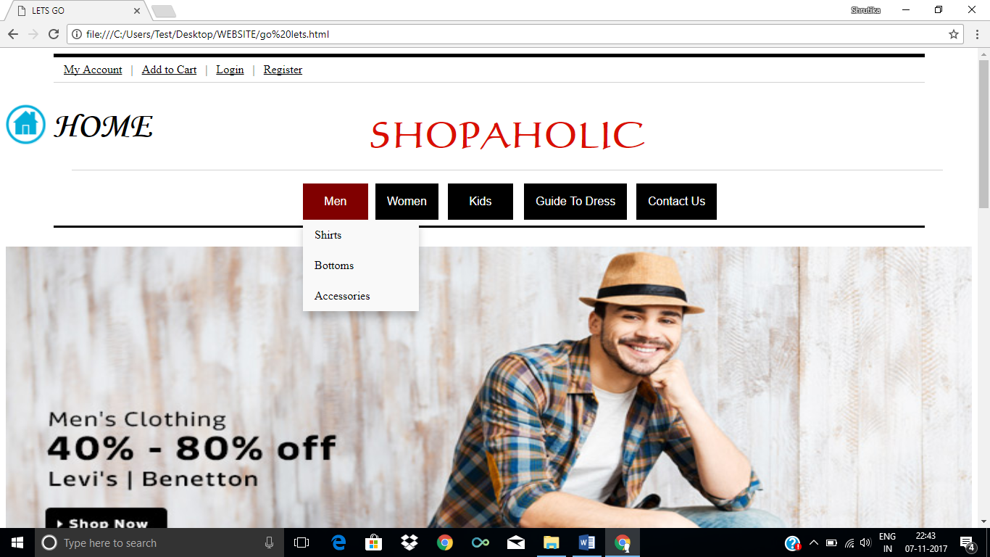

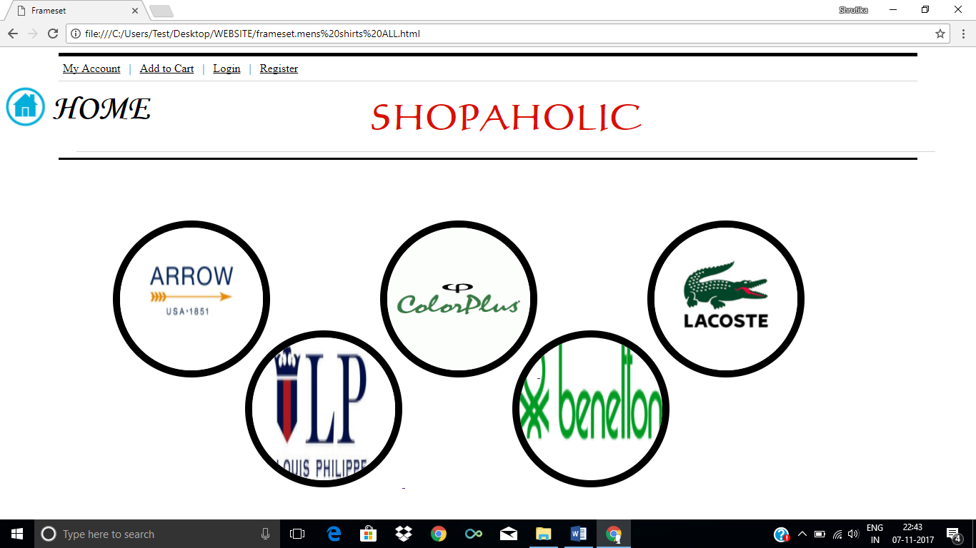

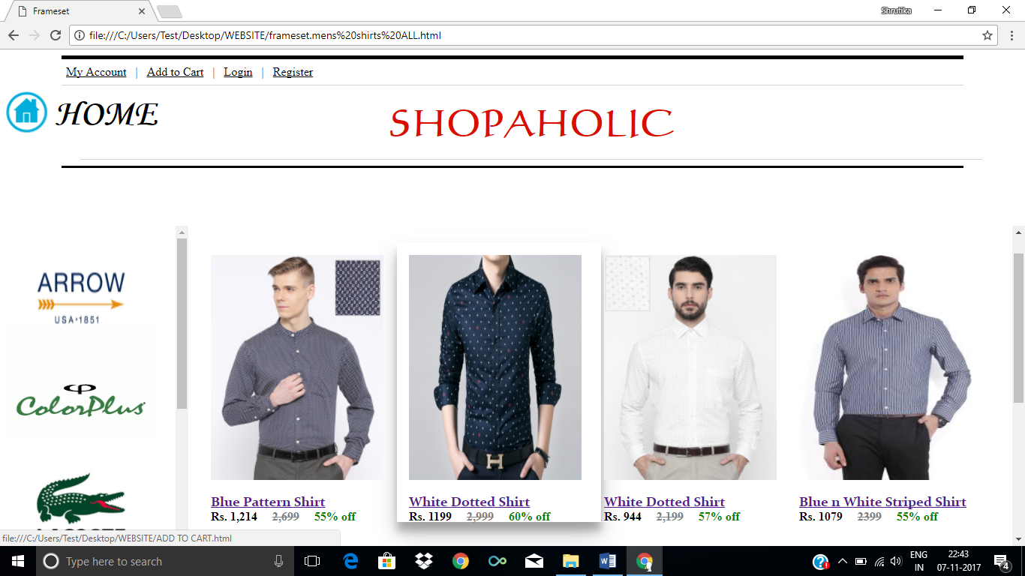

***WOMEN***

<html>

<head>

<title>Frameset womens accessories ALL</title>

</head>

<frameset rows="35%,65%" noresize>

<frame name="header" src="file:///C:/Users/Test/Desktop/WEBSITE/common%20header.html" frameborder="0">

<frame name="icons" src="file:///C:/Users/Test/Desktop/WEBSITE/women%20accessories%20ALL.html" frameborder="0">

</frameset>

</frameset>

</html>

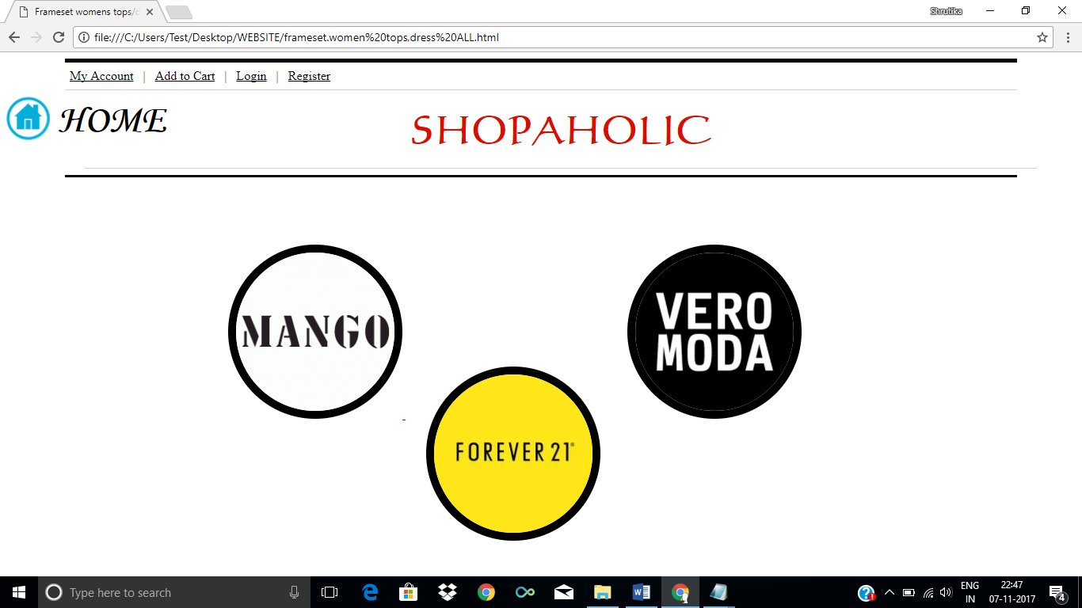

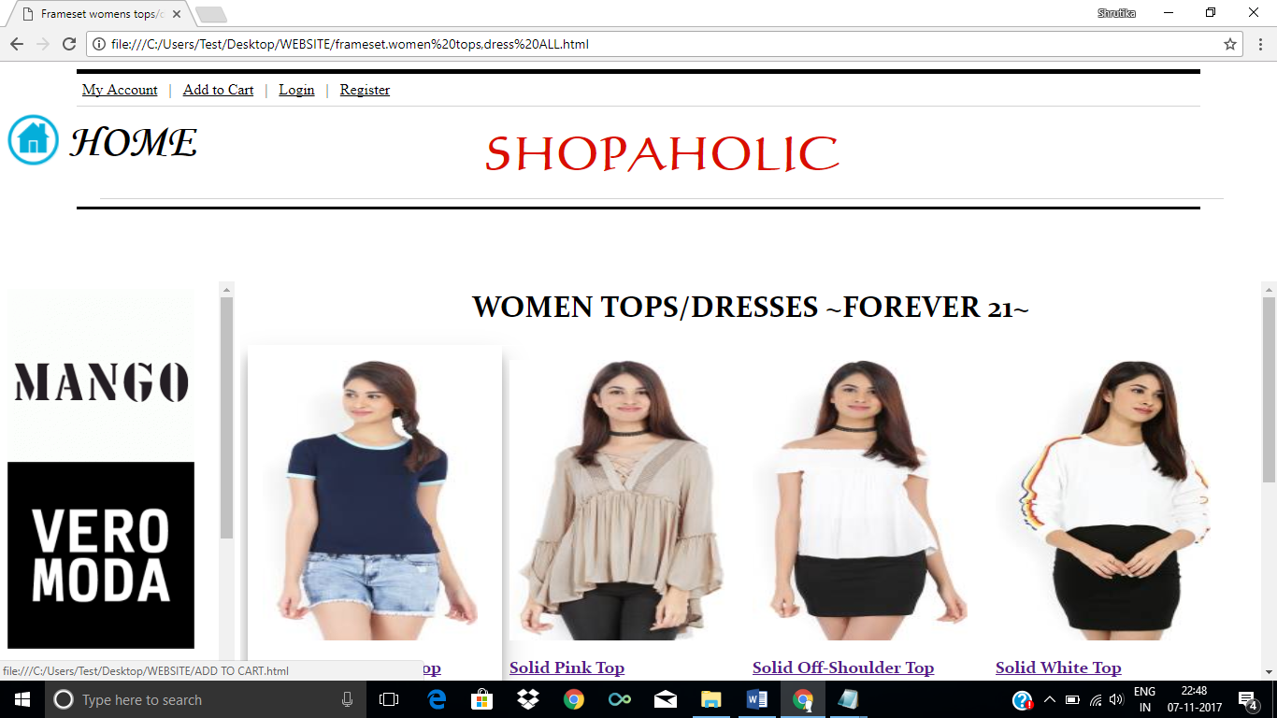

***KIDS***

<html>

<head>

<title>Frameset kids books</title>

</head>

<frameset rows="35%,65%" noresize>

<frame name="header" src="file:///C:/Users/Test/Desktop/WEBSITE/common%20header.html" frameborder="0">

<frame name="icons" src="file:///C:/Users/Test/Desktop/WEBSITE/kids%20books%20after%20icon.html" frameborder="0">

</frameset>

</frameset>

</html>

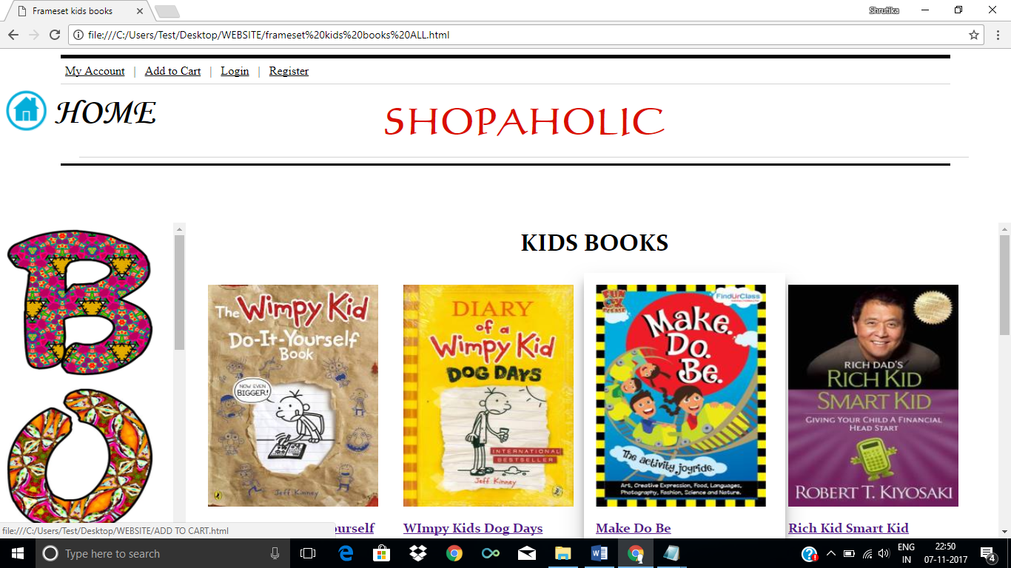

**MAIN BUTTONS**

<html>

<head>

<title>ADD TO CART</title>

<style>

body

{

background: url("nice.jpg") no-repeat 50% 50% fixed;

background-size:cover;

background-position:center;

}

.button {

display: inline-block;

padding: 15px 25px;

font-size: 24px;

cursor: pointer;

text-align: center;

text-decoration: none;

outline: none;

color: black;

background-color: pink;

border: none;

border-radius: 15px;

box-shadow: 0 9px #999;

margin-left: 300px;

margin-top: 150px;

}

.button:hover {background-color: magenta}

.button:active {

background-color: magenta;

box-shadow: 0 5px grey;

transform: translateY(4px);

}

.HOME {

margin-left: 65px;

margin-top: -70px;

}

.SHOP {

margin-left: 50px;

margin-top: -70px;

}

</style>

</head>

<body>

<hr width=1200px color=black align=top size=5>

&nbsp &nbsp &nbsp &nbsp &nbsp &nbsp &nbsp &nbsp &nbsp &nbsp <a href="file:///C:/Users/Test/Desktop/WEBSITE/my%20account.html"><font color=black>My Account</font></a> &nbsp&nbsp|&nbsp&nbsp <a href="file:///C:/Users/Test/Desktop/WEBSITE/add%20to%20cart%20form.html"><font color=black>Add to Cart</font></a>&nbsp &nbsp| &nbsp&nbsp<a href="file:///C:/Users/Test/Desktop/WEBSITE/login.html"><font color=black>Login</font></a>&nbsp&nbsp |&nbsp&nbsp <a href="file:///C:/Users/Test/Desktop/WEBSITE/register.html"><font color=black>Register</font></a>

<hr color=lightgrey width=1200px size=1>

<div class=MB>

<a href="file:///C:/Users/Test/Desktop/WEBSITE/go%20lets.html" target="_top"><img src="C:\Users\Test\Desktop\WEBSITE\unnamed.png" height=55 width=55></a>

</div>

<div class=HOME>

<h1><font face="Monotype Corsiva" size=30>HOME</font></h2>

</div>

<div class=SHOP>

<p align=top><font face="calligraph421 BT" color=darkyellow size=50><h3 align=center>SHOPAHOLIC</h1></font></p>

<hr color=lightgrey width=1200px size=1>

</div>

<hr color=black width=1200px size=3><br>

</div>

<div class=b>

<a href="file:///C:/Users/Test/Desktop/WEBSITE/ATC%20Button.html"><button class="button">ADD TO CART</button></a>

<a href="file:///C:/Users/Test/Desktop/WEBSITE/add%20to%20cart%20form.html"><button class="button">BUY</button></a>

</div>

</body>

</html>

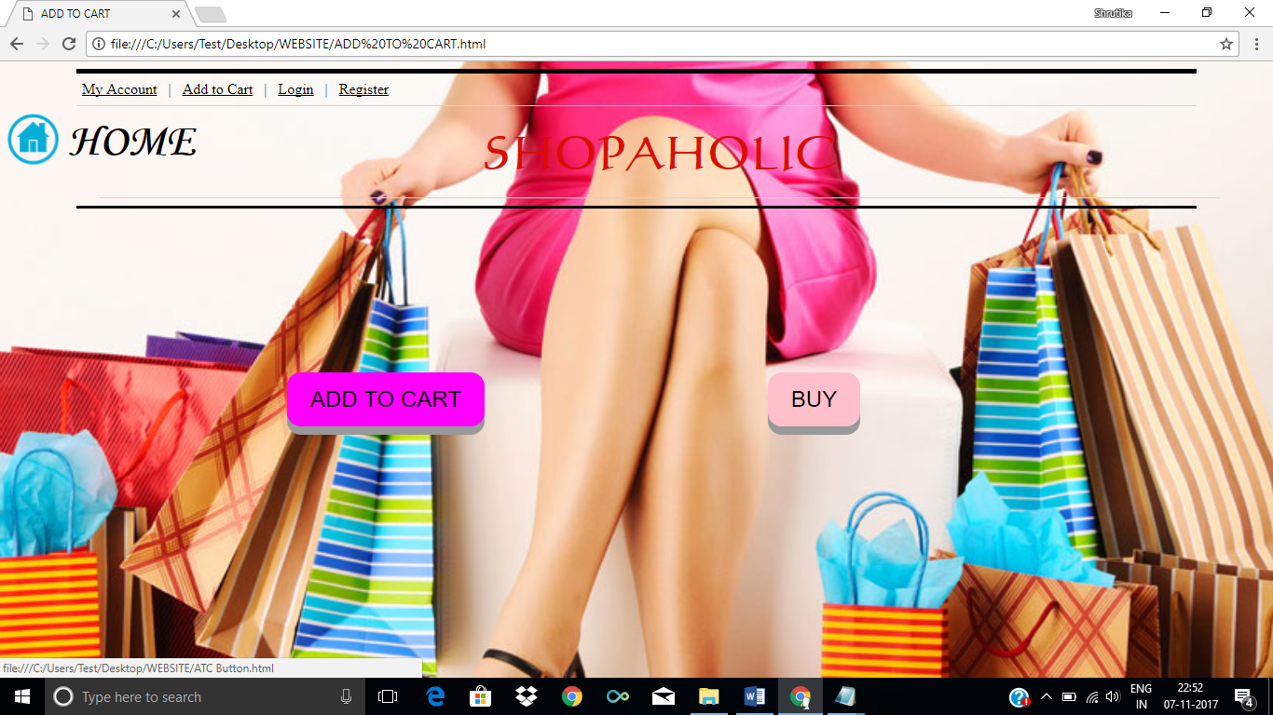

**ADD TO CART BUTTON CODING**

<html>

<head>

<title>ATC Button</title>

<style>

.HOME {

margin-left: 65px;

margin-top: -70px;

}

.SHOP {

margin-left: 50px;

margin-top: -70px;

</style>

</head>

<body>

<hr width=1200px color=black align=top size=5>

&nbsp &nbsp &nbsp &nbsp &nbsp &nbsp &nbsp &nbsp &nbsp &nbsp <a href="file:///C:/Users/Test/Desktop/WEBSITE/my%20account.html"><font color=black>My Account</font></a> &nbsp&nbsp|&nbsp&nbsp <a href="file:///C:/Users/Test/Desktop/WEBSITE/add%20to%20cart%20form.html"><font color=black>Add to Cart</font></a>&nbsp &nbsp| &nbsp&nbsp<a href="file:///C:/Users/Test/Desktop/WEBSITE/login.html"><font color=black>Login</font></a>&nbsp&nbsp |&nbsp&nbsp <a href="file:///C:/Users/Test/Desktop/WEBSITE/register.html"><font color=black>Register</font></a>

<hr color=lightgrey width=1200px size=1>

<div class=MB>

<a href="file:///C:/Users/Test/Desktop/WEBSITE/go%20lets.html" target="_top"><img src="C:\Users\Test\Desktop\WEBSITE\unnamed.png" height=55 width=55></a>

</div>

<div class=HOME>

<h1><font face="Monotype Corsiva" size=30>HOME</font></h2>

</div>

<div class=SHOP>

<p align=top><font face="calligraph421 BT" color=darkyellow size=50><h3 align=center>SHOPAHOLIC</h1></font></p>

<hr color=lightgrey width=1200px size=1>

</div>

<hr color=black width=1200px size=3><br>

<h4 align=center><font face="calligraph421 BT" color=darkyellow size=50>Your Product has been added to CART. <br> <B>THANK YOU<b></font></h4>

</body>

</html>

